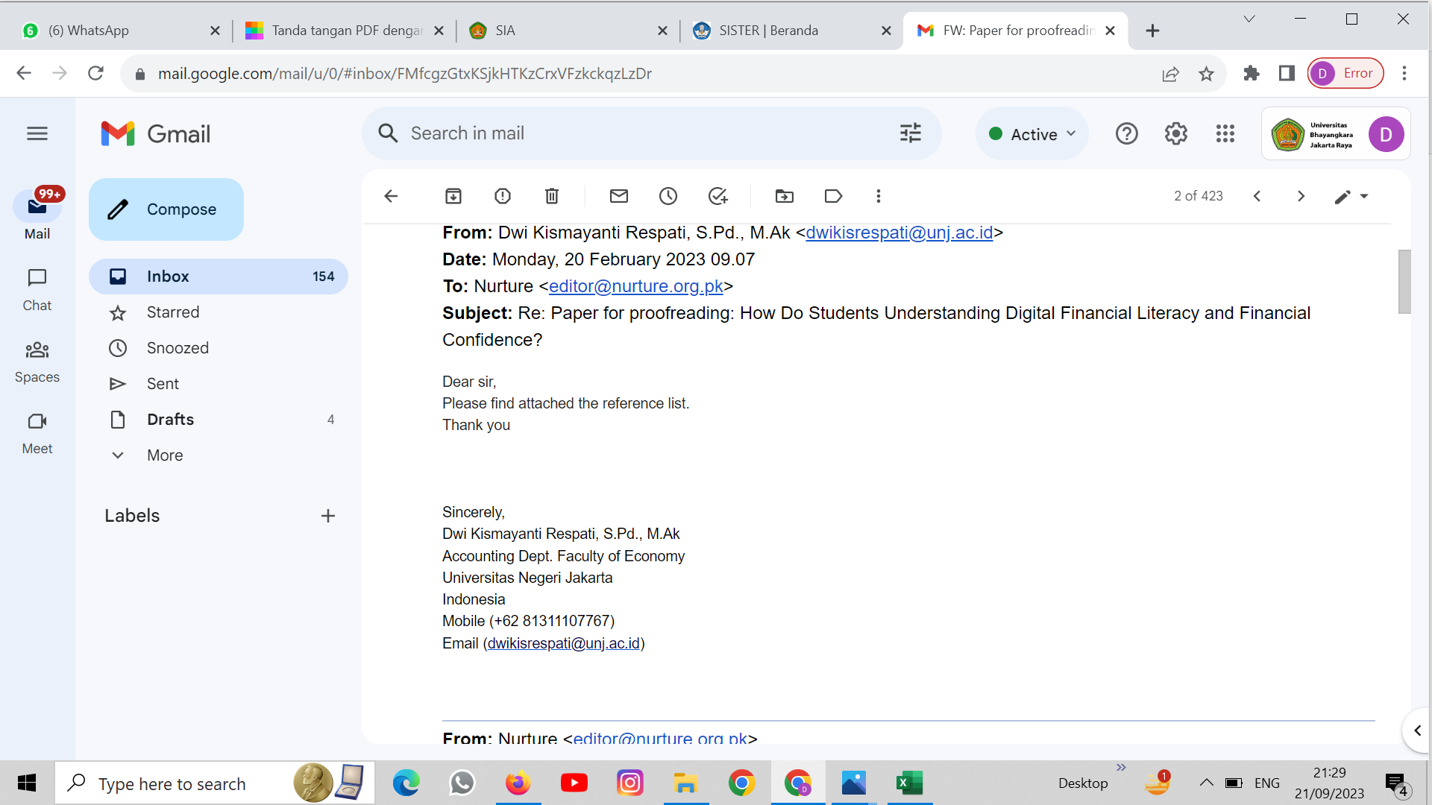
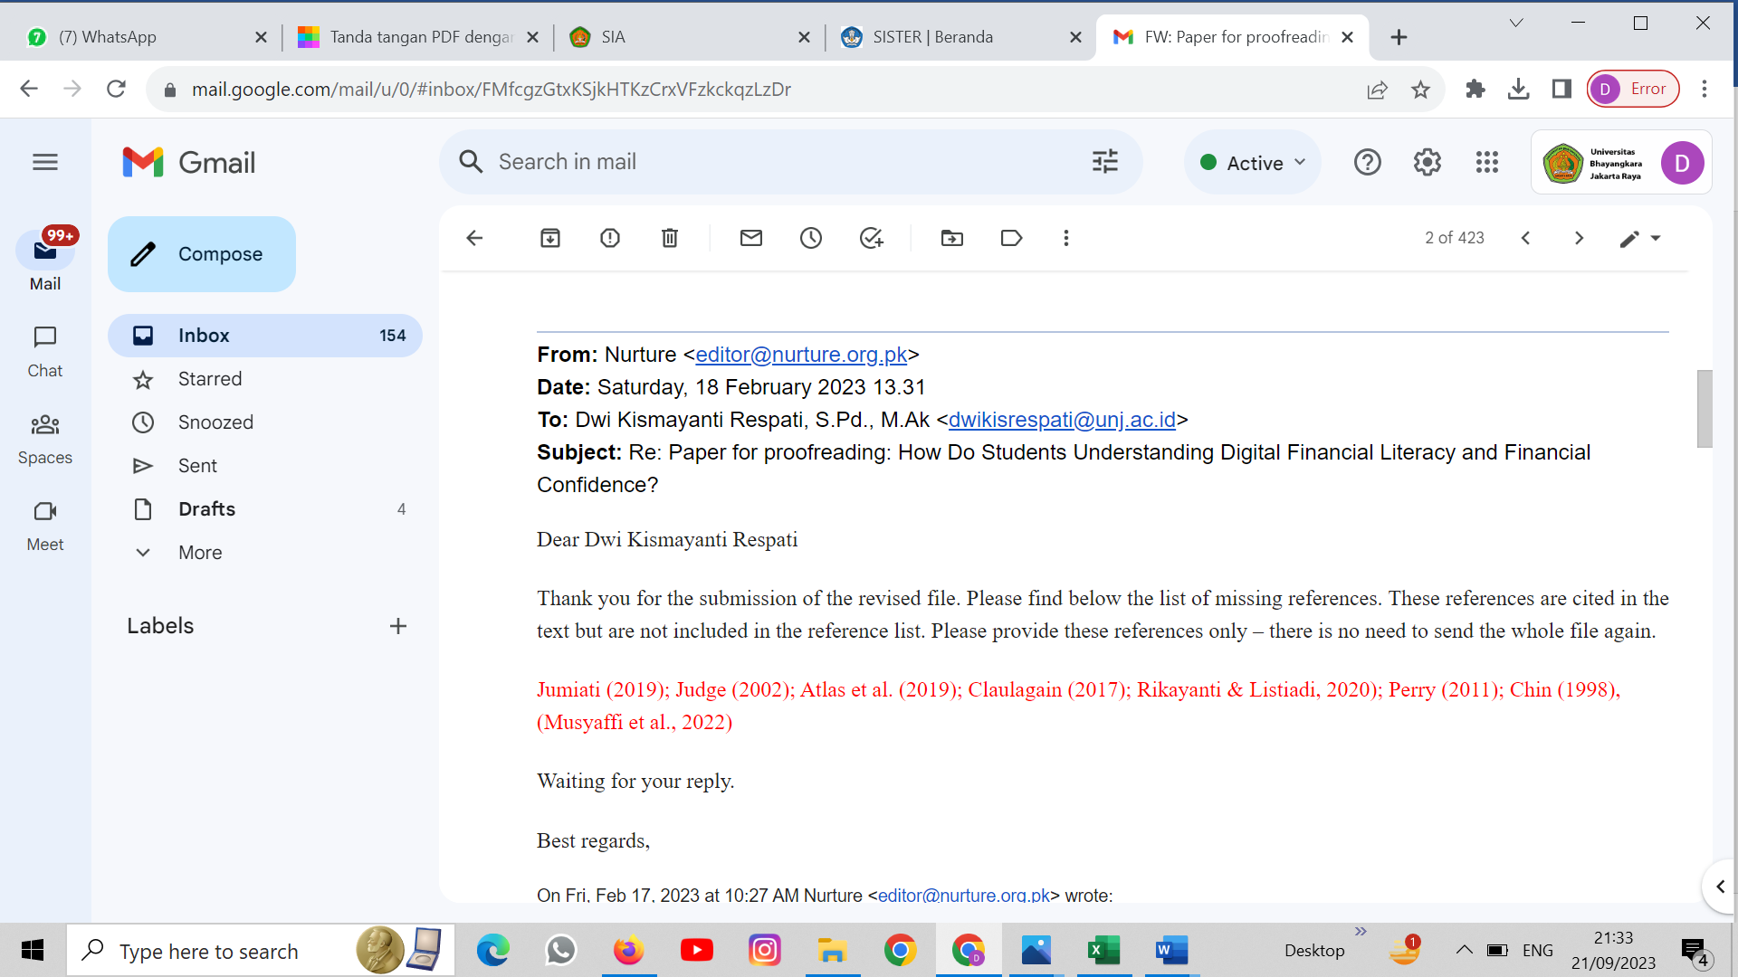
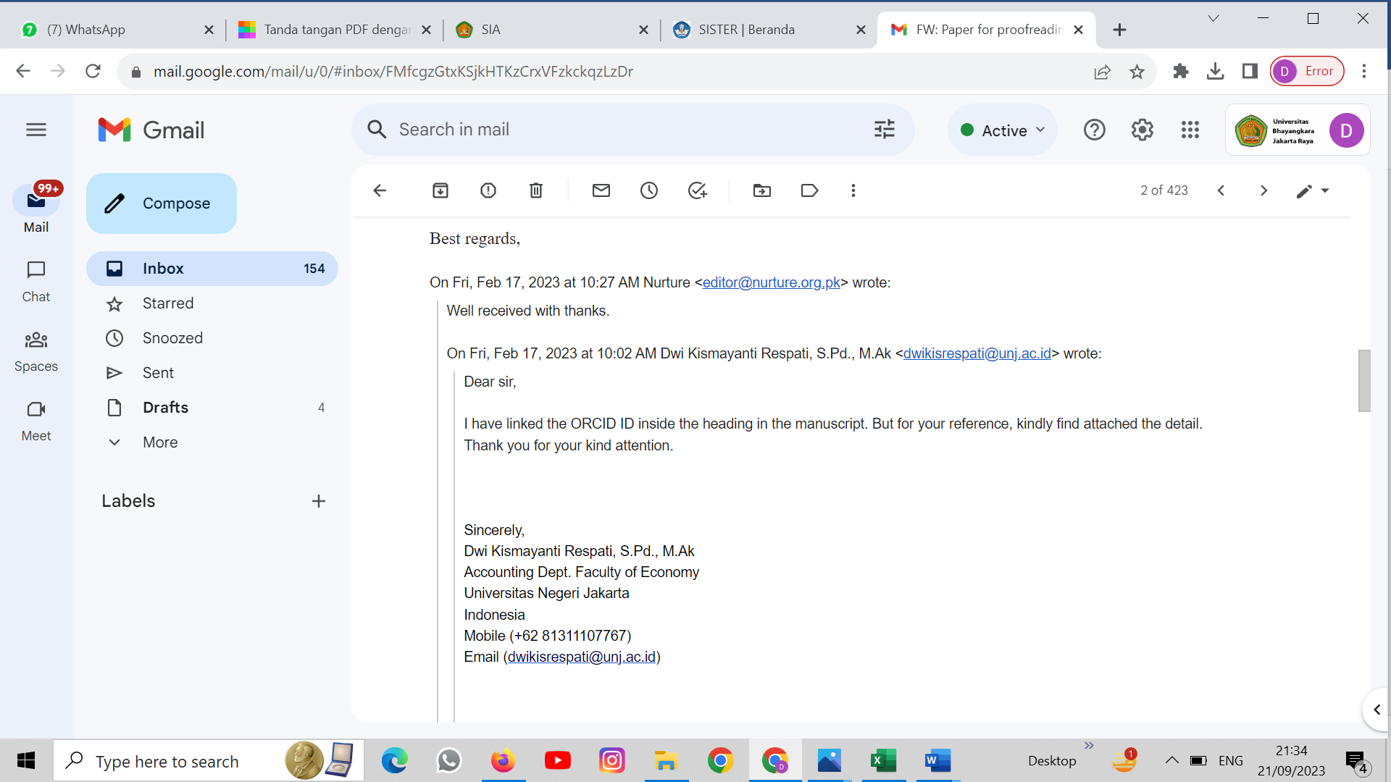
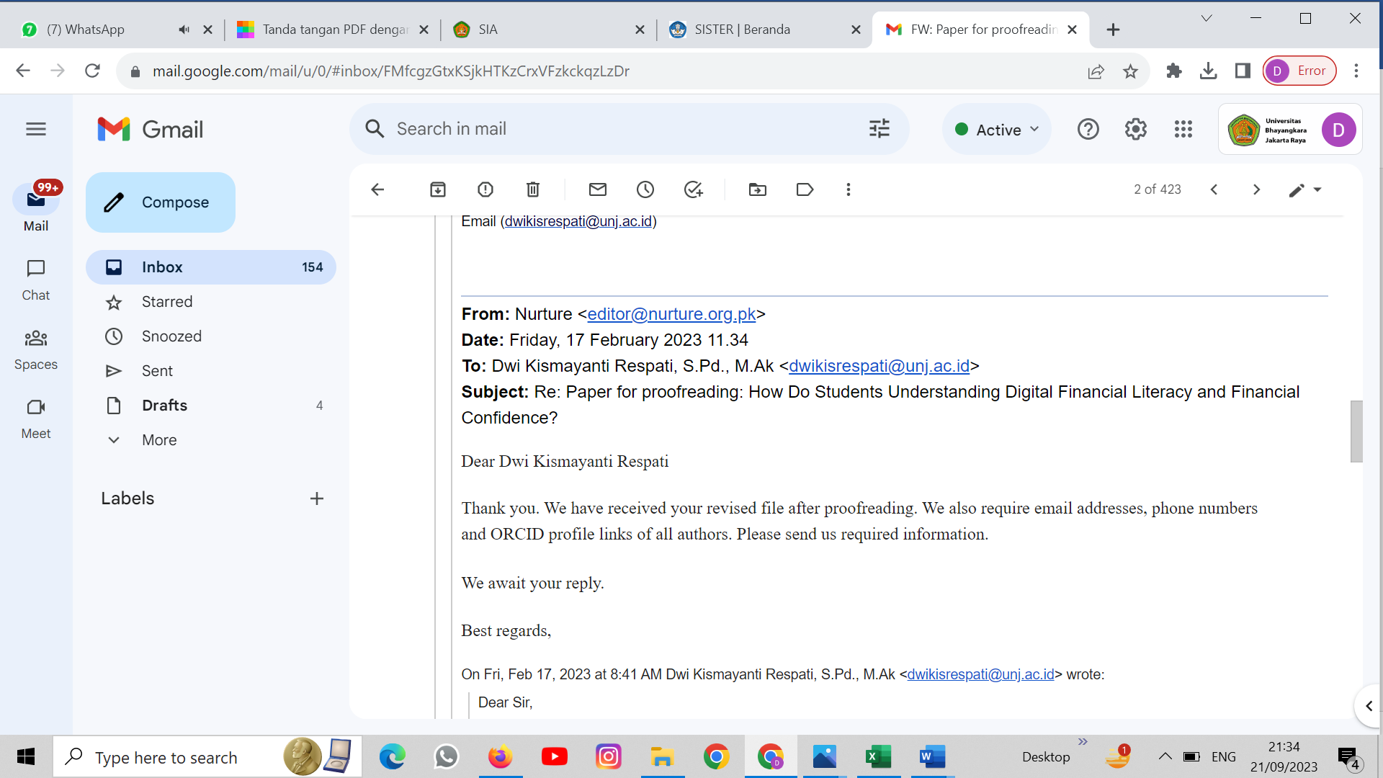
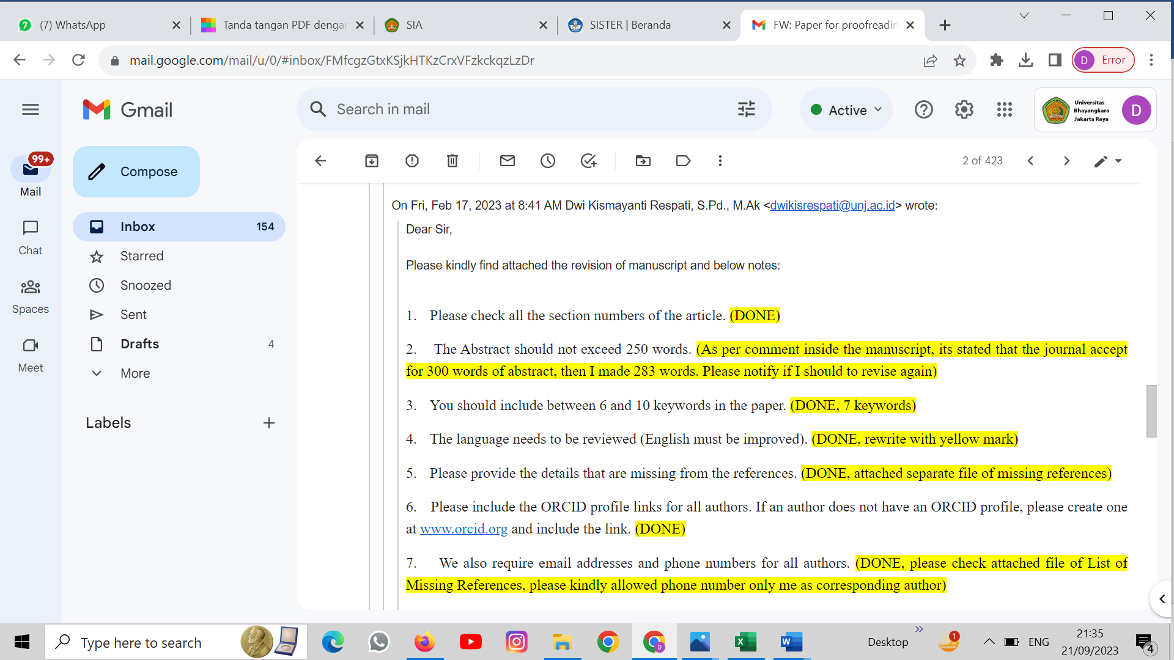
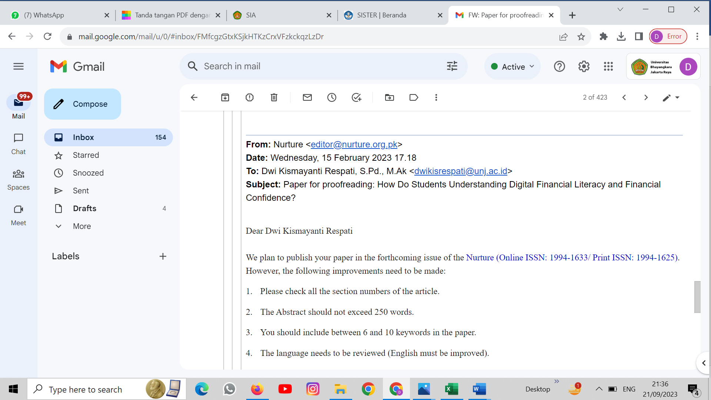
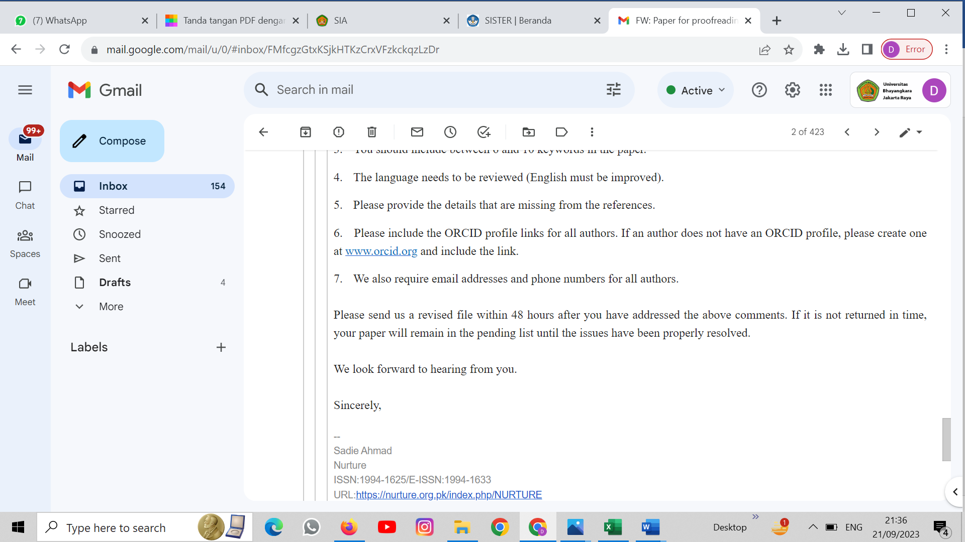

From: Dwi Kismayanti Respati, S.Pd., M.Ak <dwikisrespati@unj.ac.id>
Date: Monday, 20 February 2023 09.07
To: Nurture <editor@nurture.org.pk>
Subject: Re: Paper for proofreading: How Do Students Understanding Digital Financial Literacy and Financial Confidence?
Dear sir,
Please find attached the reference list.
Thank you

Sincerely,
Dwi Kismayanti Respati, S.Pd., M.Ak
Accounting Dept. Faculty of Economy
Universitas Negeri Jakarta
Indonesia
Mobile (+62 81311107767)
Email (dwikisrespati@unj.ac.id)

From: Nurture <editor@nurture.org.pk>
Date: Saturday, 18 February 2023 13.31
To: Dwi Kismayanti Respati, S.Pd., M.Ak <dwikisrespati@unj.ac.id>
Subject: Re: Paper for proofreading: How Do Students Understanding Digital Financial Literacy and Financial Confidence?
Dear Dwi Kismayanti Respati

Thank you for the submission of the revised file. Please find below the list of missing references. These references are cited in the text but are not included in the reference list. Please provide these references only – there is no need to send the whole file again.

Jumiati (2019); Judge (2002); Atlas et al. (2019); Claulagain (2017); Rikayanti & Listiadi, 2020); Perry (2011); Chin (1998), (Musyaffi et al., 2022)

Waiting for your reply.

Best regards,

On Fri, Feb 17, 2023 at 10:27 AM Nurture <editor@nurture.org.pk> wrote:
Well received with thanks.

On Fri, Feb 17, 2023 at 10:02 AM Dwi Kismayanti Respati, S.Pd., M.Ak <dwikisrespati@unj.ac.id> wrote:
Dear sir,

I have linked the ORCID ID inside the heading in the manuscript. But for your reference, kindly find attached the detail.
Thank you for your kind attention.

Sincerely,
Dwi Kismayanti Respati, S.Pd., M.Ak
Accounting Dept. Faculty of Economy
Universitas Negeri Jakarta
Indonesia
Mobile (+62 81311107767)
Email (dwikisrespati@unj.ac.id)

From: Nurture <editor@nurture.org.pk>
Date: Friday, 17 February 2023 11.34
To: Dwi Kismayanti Respati, S.Pd., M.Ak <dwikisrespati@unj.ac.id>
Subject: Re: Paper for proofreading: How Do Students Understanding Digital Financial Literacy and Financial Confidence?
Dear Dwi Kismayanti Respati

Thank you. We have received your revised file after proofreading. We also require email addresses, phone numbers and ORCID profile links of all authors. Please send us required information.

We await your reply.

Best regards,

On Fri, Feb 17, 2023 at 8:41 AM Dwi Kismayanti Respati, S.Pd., M.Ak <dwikisrespati@unj.ac.id> wrote:
Dear Sir,

Please kindly find attached the revision of manuscript and below notes:

1. Please check all the section numbers of the article. (DONE)
2. The Abstract should not exceed 250 words. (As per comment inside the manuscript, its stated that the journal accept for 300 words of abstract, then I made 283 words. Please notify if I should to revise again)
3. You should include between 6 and 10 keywords in the paper. (DONE, 7 keywords)
4. The language needs to be reviewed (English must be improved). (DONE, rewrite with yellow mark)
5. Please provide the details that are missing from the references. (DONE, attached separate file of missing references)
6. Please include the ORCID profile links for all authors. If an author does not have an ORCID profile, please create one at www.orcid.org and include the link. (DONE)
7. We also require email addresses and phone numbers for all authors. (DONE, please check attached file of List of Missing References, please kindly allowed phone number only me as corresponding author)

Thank you for your kind attention.

Sincerely,
Dwi Kismayanti Respati, S.Pd., M.Ak
Accounting Dept. Faculty of Economy
Universitas Negeri Jakarta
Indonesia
Mobile (+62 81311107767)
Email (dwikisrespati@unj.ac.id)

From: Nurture <editor@nurture.org.pk>
Date: Wednesday, 15 February 2023 17.18
To: Dwi Kismayanti Respati, S.Pd., M.Ak <dwikisrespati@unj.ac.id>
Subject: Paper for proofreading: How Do Students Understanding Digital Financial Literacy and Financial Confidence?

Dear Dwi Kismayanti Respati
We plan to publish your paper in the forthcoming issue of the Nurture (Online ISSN: 1994-1633/ Print ISSN: 1994-1625). However, the following improvements need to be made:
1. Please check all the section numbers of the article.
2. The Abstract should not exceed 250 words.
3. You should include between 6 and 10 keywords in the paper.
4. The language needs to be reviewed (English must be improved).
5. Please provide the details that are missing from the references.
6. Please include the ORCID profile links for all authors. If an author does not have an ORCID profile, please create one at www.orcid.org and include the link.
7. We also require email addresses and phone numbers for all authors.

Please send us a revised file within 48 hours after you have addressed the above comments. If it is not returned in time, your paper will remain in the pending list until the issues have been properly resolved.

We look forward to hearing from you.

Sincerely,

--
Sadie Ahmad
Nurture
ISSN:1994-1625/E-ISSN:1994-1633
URL:https://nurture.org.pk/index.php/NURTURE
...
[Message clipped] View entire message
One attachment • Scanned by Gmail

List of Missing References:

(Jumiati, 2009)
(Judge et al., 2002)
(Atlas et al., 2019)
(Chaulagain, 2021)
(Rikayanti & Listiadi, 2020)
(Perry, 2011)
(Chin, 1998)
(Musyaffi et al., 2022)

Atlas, S. A., Lu, J., Micu, P. D., & Porto, N. (2019). Financial knowledge, confidence, credit use, and financial satisfaction. Journal of Financial Counseling and Planning, 30(2), 175–190. https://doi.org/10.1891/1052-3073.30.2.175
Chaulagain, R. P. (2021). Relationship Between Financial Literacy and Behavior of Small Borrowers. NRB Economic Review, May, 39. https://www.researchgate.net/publication/351935208
Chin, W. W. (1998). The partial least squares approach to structural equation modeling. Modern methods for business research. Psychology Press. https://books.google.co.id/books?hl=id&lr=&id=EDZ5AgAAQBAJ&oi=fnd&pg=PA295&dq=chin+1998+pls&ots=49wG4qx0ip&sig=ia-FvSZKRCsf9QsosRataOio2FI&redir_esc=y#v=onepage&q=chin 1998 pls&f=false
Judge, T. A., Erez, A., Bono, J., & Thoresen, C. J. (2002). Are measures of self-esteem, neuroticism, locus of control, and generalized self-efficacy indicators of a common core construct? Journal of Personality and Social Psychology, 83(3), 639–710. https://doi.org/10.1037/0022-3514.83.3.693
Jumiati. (2009). Changes in Consumptive Behavior of Sunan Kalijaga State Islamic University Students Due to the Development of Value-Added Cellular Phones [Universitas Islam Negeri Sunan Kalijaga Yogyakarta]. https://digilib.uin-suka.ac.id/view/creators/JUMIATI_-_NIM=2E_04541708=3A_=3A=3A.html
Musyaffi, A. M., Johari, R. J., Rosnidah, I., Respati, D. K., Wolor, C. W., & Yusuf, M. (2022). Understanding Digital Banking Adoption During Post-Coronavirus Pandemic : An Integration of Technology Readiness and Technology Acceptance Model. TEM Journal, 11(2), 683–694. https://doi.org/10.18421/TEM112
Perry, V. G. (2011). Charging Ahead: An Exploratory Study of Financial Decision-Making among Millennial Consumers. Consumer Knowledge and Financial Decisions, 129–144. https://doi.org/10.1007/978-1-4614-0475-0_9
Rikayanti, V. R., & Listiadi, A. (2020). Pengaruh literasi keuangan, pembelajaran manajemen keuangan, dan uang saku terhadap perilaku menabung. Jurnal Pendidikan Akuntansi (JPAK), 8(3), 29–36. https://ejournal.unesa.ac.id/index.php/jpak/article/view/40669

Email Address and Phone Number:

Dwi Kismayanti Respati: email dwikisrespati@unj.ac.id , phone number: 62 81311107767
Umi Widyastuti umiwidyastuti_feunj@unj.ac.id
Tutty Nuryati tutty.nuryati@dsn.ubharajaya.ac.id
Ayatulloh Michael Musyaffi musyaffi@unj.ac.id
Bestari Dwi Handayani bestarihandayani@mail.unnes.ac.id
Najmatu Rahma Ali najmaturahma10@gmail.com

