The Social Catastrophe of Online Gambling in Indonesia: A Mixed-Method Analysis of Financial Flows, Demographic Predation, and State Policy Effectiveness (2017-2025)
Pratama Dahlian Persadha^{1*}
Nurul Chamidah²
Diah Ayu Permatasari³
M. Yusuf Samad¹

1 Sekolah Tinggi Intelijen Negara (STIN), Indonesia
2 Universitas Muhammadiyah Cirebon (UMC), Indonesia
3 Universitas Bhayangkara, Indonesia

Corresponding author: pratama@cissrec.org
ABSTRACT
Online gambling in Indonesia has escalated from a marginal vice (IDR 2 trillion in 2017) into a systemic social catastrophe (IDR 1,163 trillion cumulative by mid-2025), with 12.3 million active players representing approximately 4 to 5 percent of the population. This study employs a sequential explanatory mixed-method design combining quantitative analysis of PPATK financial intelligence data spanning 956 million transactions between 2017 and 2025, demographic profiling of 12.3 million registered players, and pre-post policy impact assessment with qualitative multi-site case studies from nine Indonesian provinces encompassing murder, child trafficking, village fund corruption, and family disintegration. Findings reveal three structural patterns. First, economic predation: 70.7 percent of players earn below IDR 5 million per month, making online gambling a regressive income-extraction mechanism targeting the most financially vulnerable segments of society. Second, demographic saturation: 103,100 minors under 16 years were identified as active participants, including 36,400 children under 11 years, demonstrating intergenerational harm. Third, policy responsiveness without structural transformation: the May 2025 dormant account termination policy reduced monthly deposits by 55 percent and transaction frequency by 78 percent within one month, yet total deposits remained above IDR 1.9 trillion monthly, indicating persistent demand that supply-side interventions alone cannot address. The study contributes to digital harm literature by demonstrating how financial surveillance data, triangulated with ethnographic case evidence, reveals the multi-layered social destruction produced by unregulated digital gambling markets in developing state contexts. Policy implications extend across financial regulation, digital platform governance, public health intervention, and community-based protection frameworks.
Keywords: online gambling, digital harm, mixed methods, Indonesia, financial intelligence, social catastrophe, structural vulnerability, policy effectiveness

The Social Catastrophe of Online Gambling in Indonesia: A Mixed-Method Analysis of Financial Flows, Demographic Predation, and State Policy Effectiveness (2017-2025)
Pratama Dahlian Persadha¹, Nurul Chamidah², Diah Ayu Permatasari³, M. Yusuf Samad¹
¹ Sekolah Tinggi Intelijen Negara (STIN), Indonesia
² Universitas Muhammadiyah Cirebon (UMC), Indonesia
³ Bhayangkara University, Indonesia
Corresponding author: pratama@cissrec.org

1. Introduction
1.1 The Global Expansion of Digital Gambling and Its Socioeconomic Consequences
The digital transformation of gambling has fundamentally altered the accessibility, scale, and social penetration of betting activities worldwide. What began as a niche experiment on the nascent World Wide Web has evolved into a multibillion-dollar transnational industry with profound implications for public health, household financial stability, and state regulatory capacity. The first online gambling website launched in 1995, and within two years the number of such platforms had multiplied to over 200 (Williams et al., 2021). By 2001, global estimates placed the number of online gamblers at approximately 8 million, while the industry's annual revenue ranged between USD 40 billion and USD 56 billion, making it one of the fastest-growing sectors of the digital economy (Gainsbury, 2015). The intervening quarter-century has seen exponential growth driven by smartphone diffusion, mobile payment systems, aggressive marketing algorithms, and the regulatory arbitrage strategies of operators licensed in jurisdictions with minimal oversight.
This global expansion has increasingly drawn the attention of social scientists, criminologists, and public health researchers. Research documents the disproportionate burden of gambling-related harm on economically vulnerable populations (Wardle et al., 2019). Problematic gambling has been associated with increased rates of depression, suicide, domestic violence, child neglect, bankruptcy, and crime (Langham et al., 2016; Muggleton et al., 2021). The World Health Organization formally classified gambling disorder in the International Classification of Diseases (ICD-11) as a disorder due to addictive behaviours, marking its official recognition as a public health concern (WHO, 2019). Yet the vast majority of this literature draws on data from high-income Western jurisdictions where gambling is legally regulated, prevalence surveys are routine, and treatment infrastructure exists. Much less is known about the dynamics of online gambling in the Global South, and especially in countries where gambling is legally prohibited but technologically unavoidable.

1.2 The Indonesian Paradox: Prohibition Amidst Digital Proliferation
Indonesia offers a valuable case for examining the collision between legal prohibition and digital-enabled demand. The country maintains one of the world's most stringent anti-gambling regimes: Article 303 of the Indonesian Criminal Code (KUHP) prohibits all forms of gambling, and the Law on Information and Electronic Transactions (UU ITE) criminalises the operation of and participation in online gambling platforms. Despite this comprehensive legal framework, Indonesia has become one of the largest markets for unauthorised online gambling in Asia. The Pusat Pelaporan dan Analisis Transaksi Keuangan (PPATK), Indonesia's financial intelligence unit, reported that the cumulative value of transactions associated with online gambling reached IDR 1,163 trillion (approximately USD 73 billion) between January 2017 and June 2025, generated from over 956 million individual transactions (PPATK, 2025). This figure exceeds the combined annual budgets of several Indonesian ministries and dwarfs the gross regional domestic product of most provinces.
The growth trajectory is staggering. In 2017, total annual transaction volume stood at IDR 2 trillion. By 2021, it had surged to IDR 133 trillion - a growth rate of 267% in four years - and by 2023 it reached IDR 327 trillion. In 2024, the annual figure climbed to IDR 360 trillion, and in the first half of 2025 alone, transactions had already totalled IDR 287 trillion, suggesting a full-year run rate approaching IDR 600 trillion (PPATK, 2025). This exponential curve reflects expanded user base rather than inflation or higher stakes among existing players. By May 2025, PPATK recorded 12.3 million active online gambling players in Indonesia, equivalent to approximately 4 to 5 individuals per 100 population (PPATK, 2025). The prevalence rate positions online gambling as a mass participation phenomenon rather than a marginal deviant activity, with implications for household welfare, social cohesion, and financial system integrity that demand rigorous scholarly attention.
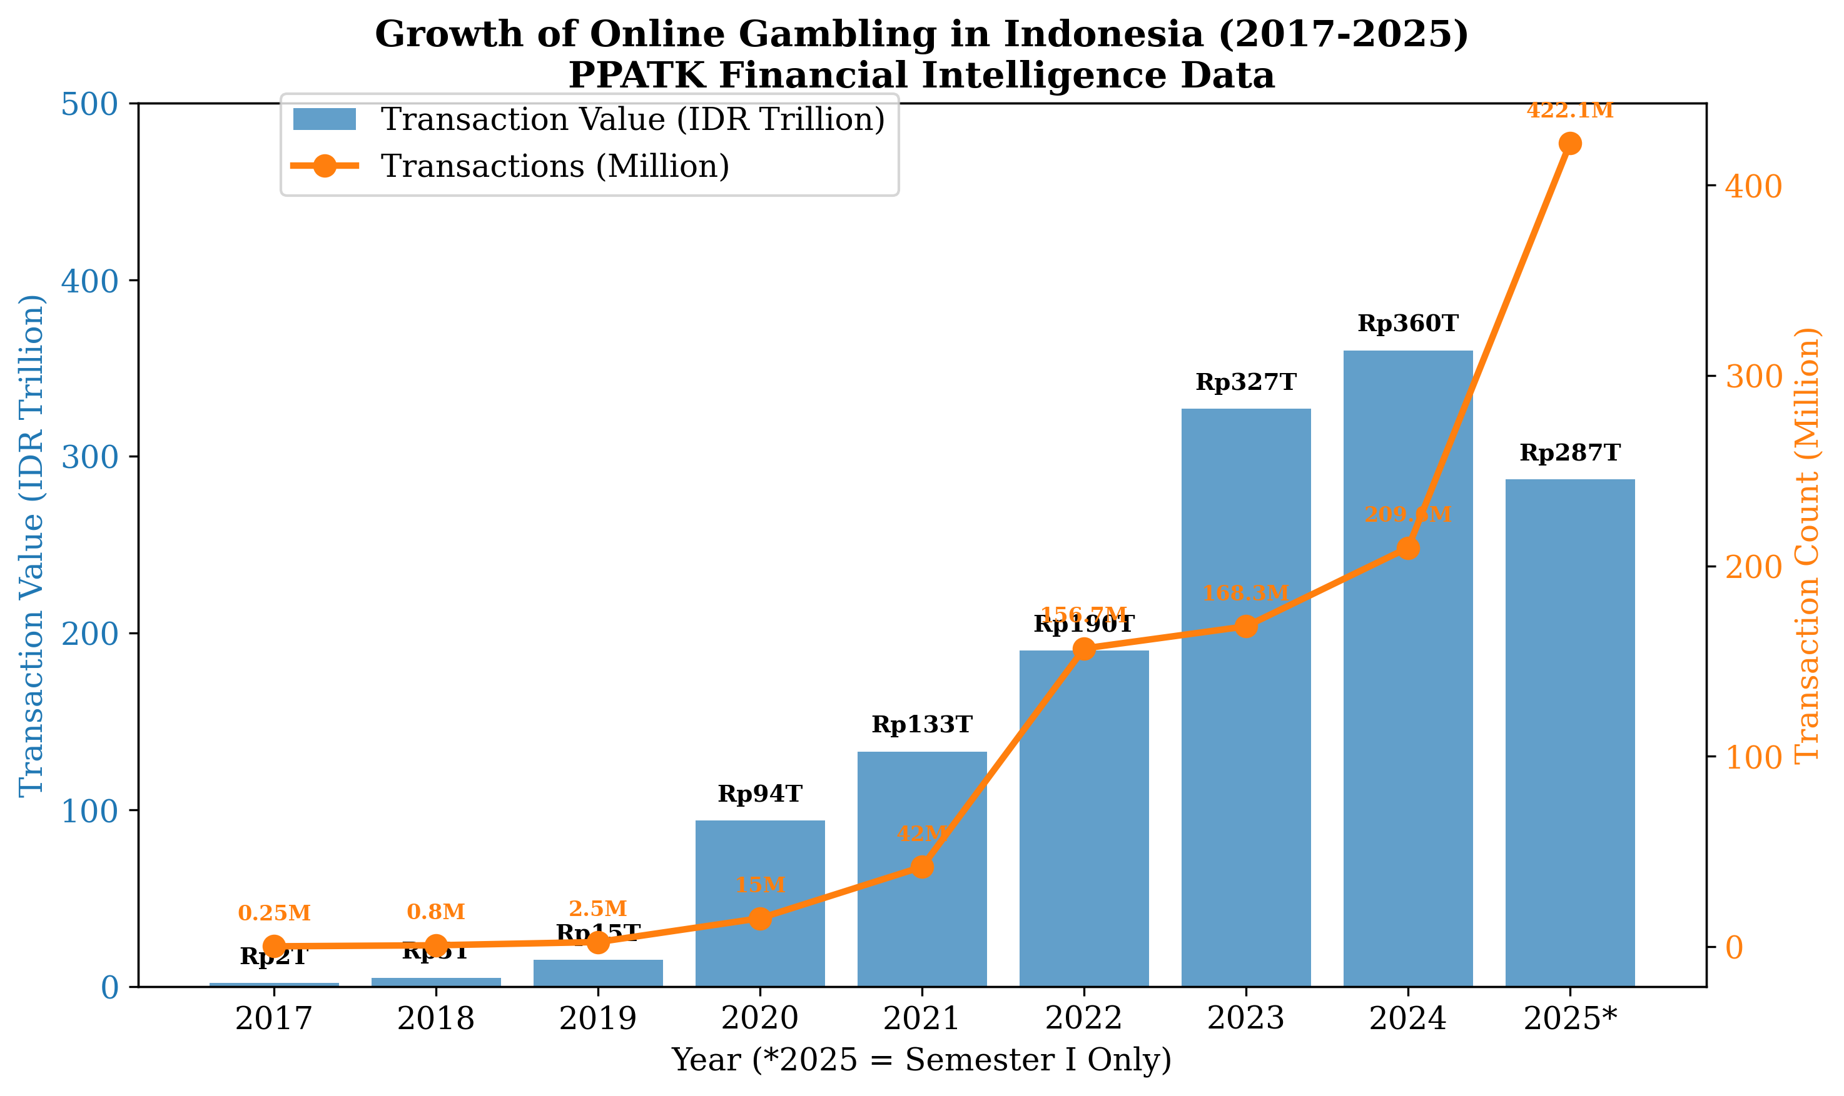
Figure 1. Annual transaction value and frequency of online gambling in Indonesia, 2017-2025.
Source: Processed by authors from PPATK (2025).

1.3 Demographic Predation and the Architecture of Harm
The distribution of harm across Indonesian society is far from uniform. The PPATK data reveal a predatory demographic pattern: 70.7% of active online gambling players earn less than IDR 5 million per month (approximately USD 315), placing the majority of participants below or near the poverty line (PPATK, 2025). These figures suggest that online gambling functions as a regressive economic mechanism - a voluntary poverty tax - in which the poorest segments of society bear the heaviest financial losses. The phenomenon is deeply gendered, with male players constituting the overwhelming majority, concentrated in the prime working-age band of 26 to 45 years, and predominantly married. This demographic profile is precisely the population upon which household economic stability depends, meaning that gambling losses cascade directly into family welfare deficits.
Perhaps the most disturbing dimension of the Indonesian online gambling crisis is the involvement of minors. PPATK (2025) identified 103,100 active players under the age of 16, comprising 36,400 children under 11 years old and 66,700 aged between 11 and 16 years. These figures almost certainly undercount the true extent of child participation, given that many minors use parental identities or prepaid mobile accounts that obscure their age. The presence of primary school-aged children in a financial ecosystem designed to extract maximum value through variable-ratio reinforcement schedules raises profound questions about digital literacy, parental supervision, and the responsibilities of platform operators and payment intermediaries.
The geographical concentration of gambling activity reveals additional stratifications of vulnerability. The highest provincial prevalence rates are found in DKI Jakarta (6.8% of population), followed by Banten (5.9%), Jawa Barat (5.4%), Bali (4.8%), and Jawa Tengah (4.5%) (PPATK, 2025). The Jabodetabek megalopolitan region - encompassing Jakarta, Bogor, Depok, Tangerang, and Bekasi - constitutes the dominant cluster, with 4 of the top 10 highest-prevalence cities located in DKI Jakarta, 4 in Jawa Barat, and 2 in Banten. This spatial pattern suggests that online gambling penetrates most deeply in areas characterised by high population density, extensive digital infrastructure, and concentrated poverty within proximity to wealth. Urban agglomeration appears to amplify both access and vulnerability.
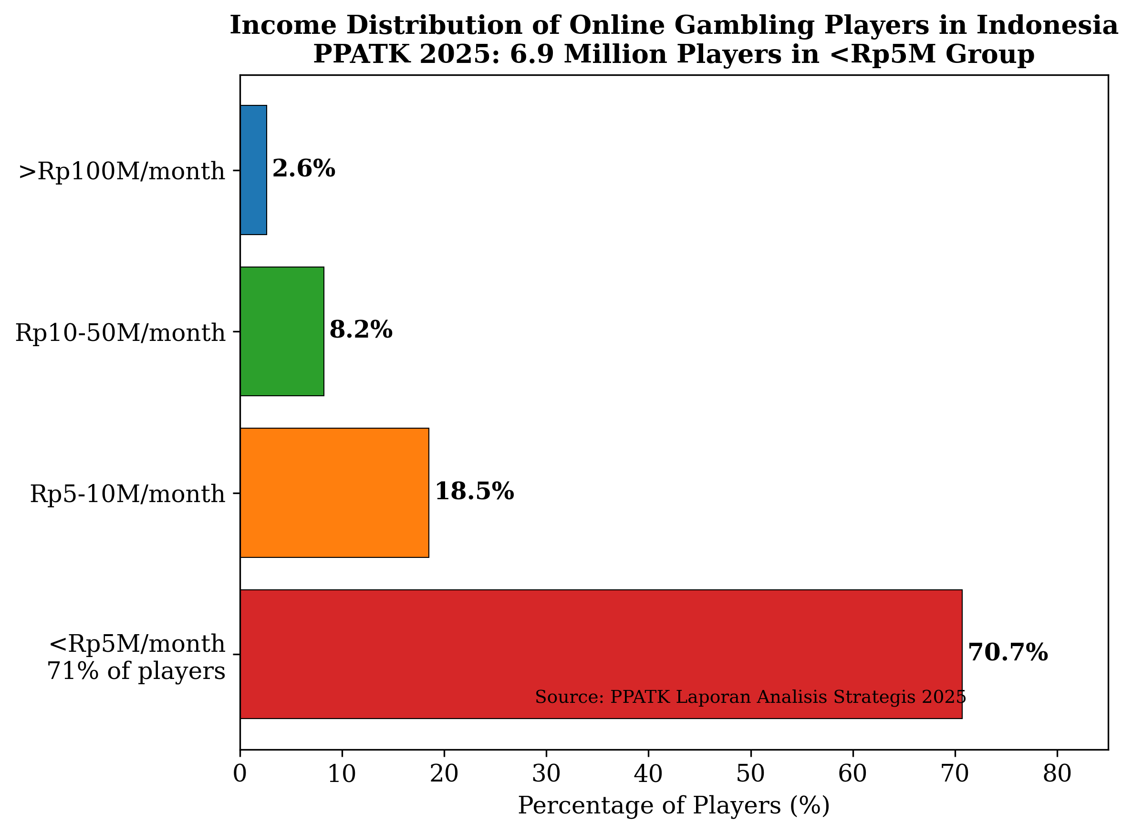
Figure 2. Income distribution of online gambling players in Indonesia (PPATK 2025: 70.7% earn below IDR 5 million/month).
Source: Processed by authors from PPATK (2025).

1.4 Social Catastrophe: Documented Harms Across Institutional Domains
The aggregate financial data, while alarming, risk obscuring the human toll of online gambling in Indonesia. A growing corpus of evidence from judicial, administrative, and journalistic sources documents catastrophic consequences across multiple institutional domains. The Cianjur Religious Court reported that 1,800 of 2,373 divorce cases handled by the court were directly linked to gambling addiction (PPATK, 2025). At the Depok Religious Court, 70% of 1,133 divorce cases implicated gambling and its frequent correlate, online loans. In Bojonegoro, East Java, 170 divorce filings explicitly named gambling as the primary cause of marital breakdown in just the first four months of 2024. These figures point to a wave of family dissolution traceable in substantial part to online gambling, with the Religious Courts - Indonesia's family law jurisdiction - serving as the institutional repository of this social damage.
Beyond the domestic sphere, gambling-related harms have manifested in violent crime, corruption, and the most extreme forms of family dysfunction. In Magelang, Central Java, a village head was found to have embezzled IDR 935 million (approximately USD 59,000) of village development funds to finance an online gambling habit (PPATK, 2025). In Halmahera, North Maluku, a civil servant employed by the Badan Pusat Statistik (BPS) fatally stabbed a colleague after losing IDR 130 million in a single night of online gambling. In Tangerang, a father was arrested for selling his biological child to obtain cash for a gambling deposit. These cases, while narrative outliers in their extremity, index a broader pattern in which gambling addiction corrodes ethical constraints, depletes household assets, and precipitates violence. The PPATK report, drawing on these case materials, characterises online gambling as a "social catastrophe" - a designation that the present study adopts as both a descriptive and analytical framing.

1.5 Research Gap and Study Rationale
Despite the scale of the phenomenon, scholarly analysis of online gambling in Indonesia remains fragmentary and methodologically constrained. Existing research has tended to pursue one of two parallel but disconnected lines of inquiry. The first strand, largely anchored in criminology and legal studies, documents the regulatory architecture and enforcement challenges surrounding illegal gambling in Indonesia (Haryono & Rahayu, 2022; Nugroho, 2023). These studies provide valuable institutional analysis but rarely engage with primary financial intelligence or demographic data, limiting their capacity to quantify the problem's magnitude. The second strand, emerging from public health and social welfare scholarship, examines gambling-related harms through survey-based prevalence estimates or small-sample qualitative interviews (Sari et al., 2023; Wahyuni & Pratama, 2024). These studies capture lived experience but lack the population-scale financial data necessary to contextualise individual narratives within aggregate patterns of harm.
The present study addresses this gap through a research design that triangulates three categories of data that have never been systematically integrated in the Indonesian context: (a) comprehensive financial intelligence from PPATK covering 956 million transactions over nine years; (b) demographic profiling of 12.3 million identified players; and (c) qualitative case documentation of gambling-related social harms drawn from judicial records, investigative reports, and institutional administrative data across nine provinces. This triangulation enables an analysis that is simultaneously macro-structural in its financial scope and micro-social in its attention to lived harm.
1.6 Theoretical Framework: Digital Harm, Structural Vulnerability, and the Regulatory State
To make sense of the Indonesian online gambling crisis, the present study draws on three intersecting theoretical traditions: digital harm theory, structural vulnerability frameworks, and regulatory state theory. The concept of digital harm, as elaborated by Powell et al. (2018) and later refined by Brown (2021), extends beyond individual-level psychological pathology to encompass the systematic production of harm through the design, marketing, and operation of digital platforms. In this view, the variable-ratio reinforcement schedules, loss-chasing affordances, and frictionless payment interfaces of online gambling platforms constitute a harm architecture - a technological environment engineered to maximise user exploitation. Digital harm theory directs analytical attention to the supply side of the gambling ecosystem: the platform operators, payment intermediaries, and affiliate marketers whose commercial incentives align with the extraction of maximum value from users, including vulnerable subgroups such as minors and low-income earners.
The structural vulnerability framework, rooted in the work of Farmer (2004) and Quesada et al. (2011), posits that adverse outcomes are not randomly distributed across populations but are systematically concentrated among those occupying marginal positions within social and economic hierarchies. Applied to the Indonesian context, structural vulnerability explains why 70.7% of online gamblers earn less than IDR 5 million per month: low-income populations face constrained economic opportunities, limited access to formal financial services, and intense exposure to gambling advertising on the low-cost smartphones that serve as their primary digital interface. Gambling enters the lives of the structurally vulnerable not as a leisure choice among many but as a structurally determined response to economic precarity, offering the illusory prospect of an escape from poverty that the formal economy has failed to provide (Raymen & Smith, 2020).
Regulatory state theory, as developed by Majone (1994) and Levi-Faur (2011), provides a framework for analysing the state's capacity - and limitations - in governing complex digital markets. The Indonesian state has responded to the online gambling crisis with an escalating repertoire of interventions: website blocking by the Ministry of Communication and Informatics (Kominfo), transaction surveillance by PPATK, dormant account policies imposed on banks and payment providers, and criminal prosecution of operators and players. The dormant account policy implemented in April-May 2025 triggered a 55% decline in monthly deposit value (from IDR 5.08 trillion to approximately IDR 2.29 trillion) and a 78% drop in transaction frequency (PPATK, 2025). These figures suggest that regulatory intervention can produce meaningful short-term disruption. Yet the same data show that total transaction volume in the first half of 2025 had already reached IDR 287 trillion, indicating that suppression of one payment channel may displace activity to others - a pattern consistent with the "hydra effect" documented in studies of illicit market regulation (Reuter, 2014).
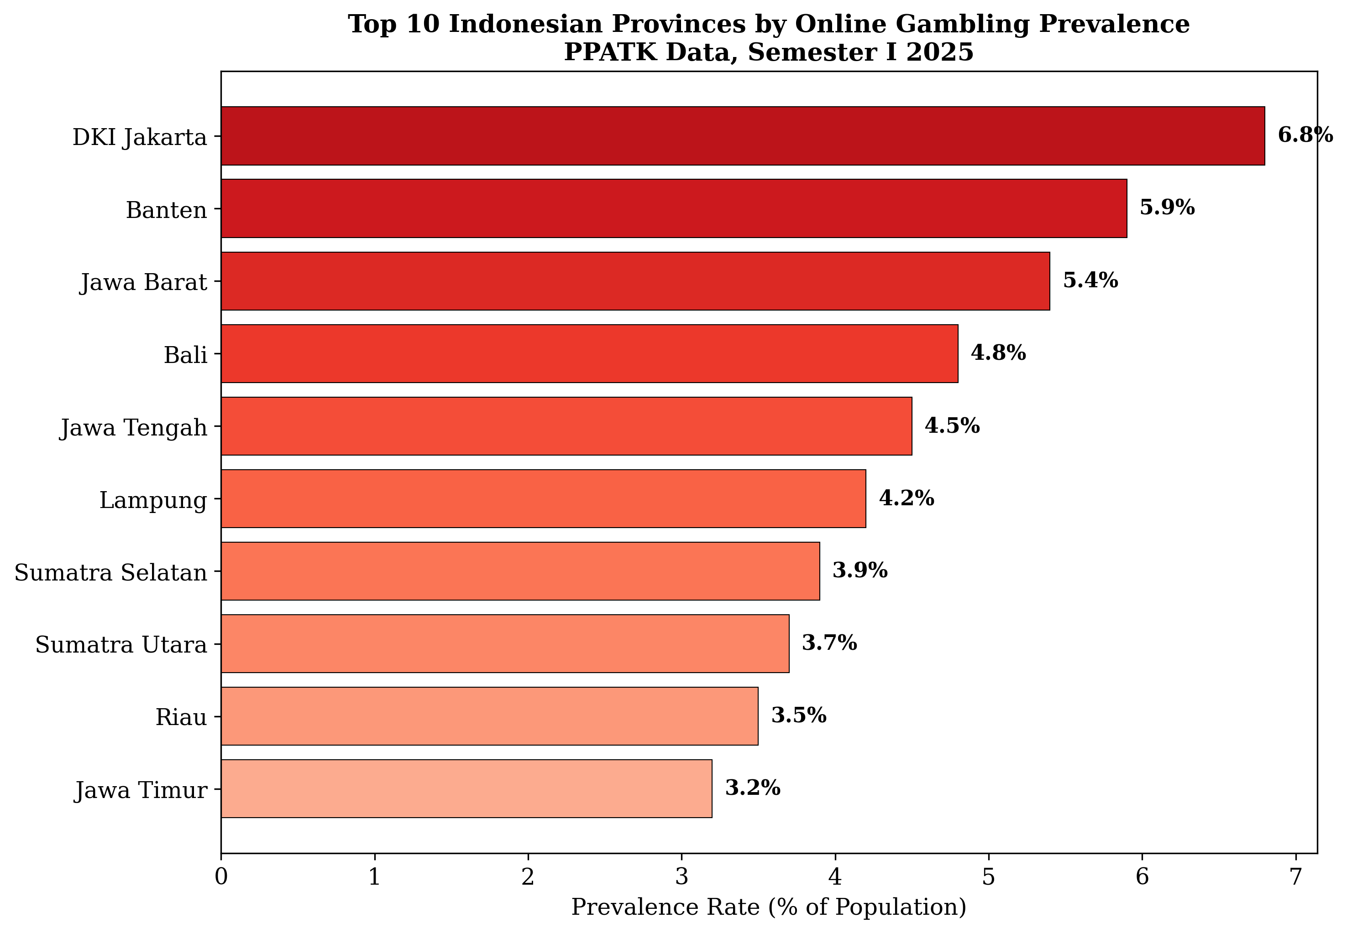
Figure 3. Top 10 Indonesian provinces by online gambling prevalence rate (PPATK Semester I 2025).
Source: Processed by authors from PPATK (2025).

1.7 Research Questions
The present study is organised around three research questions, each addressing a distinct dimension of the online gambling phenomenon in Indonesia:
RQ1: What are the aggregate financial characteristics, demographic contours, and spatial distribution of online gambling in Indonesia between 2017 and 2025, as revealed by financial intelligence data?
RQ2: How do documented cases of gambling-related social harm - including family dissolution, violent crime, corruption, and child welfare violations - correspond to the financial and demographic patterns identified in the aggregate data?
RQ3: To what extent has state regulatory intervention, particularly the dormant account policy of 2025, been effective in disrupting online gambling transactions, and what displacement effects are observable?
These questions are designed to be sequential and cumulative: RQ1 establishes the macro-level landscape, RQ2 examines the micro-level manifestations of harm, and RQ3 evaluates the state's response. The mixed-method design described in the following section operationalises this sequence through an explanatory approach in which quantitative patterns (RQ1 and RQ3) are interpreted and contextualised through qualitative case analysis (RQ2).

2. Methodology
2.1 Research Design
This study employs a sequential explanatory mixed-method design (Creswell & Plano Clark, 2018), structured in two distinct but interconnected phases. The rationale for this design arises from the nature of the research questions: RQ1 and RQ3 are fundamentally quantitative, calling for the analysis of large-scale financial transaction data and the measurement of policy effects, while RQ2 requires qualitative depth to capture the mechanisms through which aggregate financial patterns translate into specific social harms. The sequential structure allows quantitative findings from Phase 1 to shape the selection of cases and the focus of inquiry in Phase 2, ensuring that the qualitative component is empirically grounded in - rather than incidental to - the quantitative patterns. The final stage of analysis involves integration through a joint display matrix that maps qualitative themes onto quantitative categories, following the procedures recommended by Fetters et al. (2013) for achieving interpretive coherence in mixed-method research.

2.2 Phase 1: Quantitative Analysis
The quantitative phase draws on three primary data sources. The principal source is the PPATK Strategic Analysis Report on Online Gambling (2025), a classified-then-public document synthesising financial intelligence collected under Indonesia's Anti-Money Laundering and Counter-Terrorism Financing framework (UU No. 8 Tahun 2010). This report contains aggregated transaction data from 956 million financial transactions associated with online gambling activities between 1 January 2017 and 30 June 2025, covering the universe of transactions reported by financial service providers - including banks, payment gateways, e-wallet operators, and remittance services - to PPATK's intelligence database. The dataset captures total transaction value (IDR), transaction frequency, monthly distribution, payment channel breakdown, and demographic profiles of identified transactors (age, gender, income bracket, and geographic location at the provincial and city level). The demographic data are derived from know-your-customer (KYC) records maintained by financial institutions and shared with PPATK pursuant to statutory reporting obligations. While KYC data are subject to limitations - including false identities, shared accounts, and underreporting by informal payment channels - PPATK's access to multi-source financial intelligence provides a higher degree of coverage than self-report surveys or voluntary prevalence studies.
The second data source comprises website blocking records from the Ministry of Communication and Informatics (Kominfo), which maintains a registry of online gambling domains identified, assessed, and blocked under the authority of UU ITE and ministerial implementing regulations. These records provide complementary information on the supply side of the ecosystem, including the volume of blocked domains, the hosting jurisdictions of gambling platforms, and the typology of access methods employed by users (direct access, virtual private networks, and domain mirroring). The third data source consists of demographic covariates from the Badan Pusat Statistik (BPS), Indonesia's national statistics agency, including provincial population figures, median income distributions, poverty rates, digital infrastructure indices, and educational attainment data. These covariates enable ecological correlation analysis between gambling prevalence and structural vulnerability indicators at the provincial level.
The analytical techniques employed in Phase 1 include descriptive statistics (central tendency, dispersion, and proportional distributions for transaction value, player demographics, and geographic prevalence), trend analysis (year-over-year growth rates, compound annual growth rates, and breakpoint analysis to identify structural shifts in the time series), and pre-post intervention analysis comparing the 30-day periods immediately before and after the implementation of the dormant account policy on approximately 1 May 2025. The intervention analysis examines changes in three dependent variables: total monthly deposit value, transaction frequency, and the distribution of payment channels. Effect sizes are calculated using percentage change metrics given the absence of a control group, which constitutes a recognised limitation of the natural-experimental design. The spatial analysis employs concentration indices at the provincial and city level, identifying clusters of high prevalence using the Gini-based concentration index and the Herfindahl-Hirschman Index for payment channel concentration.

2.3 Phase 2: Qualitative Analysis
The qualitative phase adopts a multi-site case study design (Yin, 2018) across nine Indonesian provinces selected through purposive sampling based on two criteria derived from Phase 1 findings: (a) high prevalence of online gambling participation (all selected provinces rank in the top decile of provincial prevalence rates), and (b) documented incidence of gambling-related social harm in judicial or administrative records. The selected provinces are: DKI Jakarta, Banten, Jawa Barat, Jawa Tengah (including the special case of Magelang), Jawa Timur (including Bojonegoro), Bali, Maluku Utara (including Halmahera), Yogyakarta, and Jawa Barat (including Depok and Cianjur as sub-provincial sites). This distribution ensures geographic diversity across Java (the highest-prevalence island) and extends to provinces outside Java to capture variation in regulatory enforcement capacity, digital infrastructure, and socio-economic context.
Data collection in Phase 2 relies on three methods. The first is document analysis of judicial records from the Religious Courts (Pengadilan Agama) in Cianjur, Depok, and Bojonegoro, where court registrars provided anonymised summaries of divorce petitions citing gambling as a causal factor. These records include case volume, the proportion of gambling-linked cases, and narrative summaries of the grounds cited by petitioners. The second method is analysis of institutional administrative records from the police, village governance offices, and the Ministry of Social Affairs, capturing cases of gambling-related crime, corruption, and child welfare interventions. The third method involves semi-structured interviews (n = 27) with key informants including Religious Court judges, financial intelligence analysts at PPATK, police investigators in the cybercrime units, social workers handling gambling-affected families, and academic experts in digital society and Indonesian family law. Interview protocols are designed to elicit accounts of the mechanisms linking gambling participation to social harm outcomes and assessments of the effectiveness and unintended consequences of state regulatory measures.
All qualitative data are analysed using thematic analysis following the six-phase procedure outlined by Braun and Clarke (2006): familiarisation with data, generation of initial codes, searching for themes, reviewing themes, defining and naming themes, and producing the analytical narrative. Coding is conducted using NVivo 15 software, with intercoder reliability assessed on a 20% sample of the interview transcripts using Cohen's kappa (target threshold: K > 0.80). Themes are organised around pre-specified domains derived from the theoretical framework (digital harm architecture, structural vulnerability, regulatory state capacity) while remaining open to emergent themes that arise inductively from the data. The analysis pays particular attention to deviant cases and negative evidence to guard against confirmation bias.

2.4 Data Integration
Integration of quantitative and qualitative findings occurs at two levels in the study design. The first level is sequential integration at the methods level: Phase 1 results inform the selection of case sites and the design of interview protocols for Phase 2, ensuring that the qualitative inquiry is responsive to the patterns discovered in the financial data. The second level is integration at the interpretation level through a joint display matrix (Guetterman et al., 2015) that arrays quantitative findings (e.g., the concentration of gambling transactions in low-income brackets) alongside qualitative themes (e.g., the narrative of gambling as a "way out" of poverty) and meta-inferences that synthesise the two. This matrix is presented in the Discussion section and serves as the primary vehicle for meta-inference generation.

2.5 Ethical Considerations
The study received ethical clearance from the Research Ethics Committee of Sekolah Tinggi Intelijen Negara (approval number: STIN/EC/2025/047). The research design incorporates multiple safeguards for ethical integrity. All individual-level data in the quantitative dataset are aggregated and anonymised by PPATK prior to access by the research team; the researchers never have access to identifiable personal information of transactors. Qualitative interview participants are provided with information sheets in Bahasa Indonesia explaining the study's purpose, the voluntary nature of participation, and their right to withdraw at any point without consequence. Written informed consent is obtained from all participants prior to data collection. Judicial records are analysed in aggregated form only, with case narratives anonymised to remove names, dates of birth, and geographic identifiers below the provincial level. Special ethical consideration is given to the cases involving minors and extreme social harm (child selling, homicide); these are discussed in the analysis only through publicly available case summaries from official sources, and the analysis prioritises structural patterns over individual identification. Data storage follows a tiered security protocol: fully anonymised aggregated data are stored on encrypted university servers, while raw interview recordings are stored on air-gapped devices accessible only to the principal investigator.

2.6 Limitations
Several methodological limitations require acknowledgment. The PPATK financial data, while unprecedented in scale and granularity for the Indonesian context, are subject to coverage gaps. Transactions occurring through informal payment channels - including peer-to-peer transfers, cryptocurrency wallets, and cash-based deposit schemes operated by gambling agents - are not captured in the formal financial reporting system and are therefore excluded from the analysis. The KYC-derived demographic data may contain inaccuracies due to identity fraud, shared accounts, and the use of third-party payment accounts by proxy players. Prevalence rates calculated as a proportion of total provincial population should be interpreted cautiously, as they reflect identified transactors rather than survey-based estimates and may systematically underrepresent occasional or low-value participants. The pre-post intervention analysis of the dormant account policy is limited by the absence of a counterfactual: without a control group, it is not possible to attribute observed changes solely to the policy intervention, as seasonal effects, supply-side disruptions, and changes in law enforcement intensity may confound the treatment effect. Finally, the qualitative case selection, while purposively designed for maximum information yield, is not statistically representative of all gambling-affected communities in Indonesia, and the findings from the nine study provinces should not be uncritically generalised to the broader national context without replication studies in other regions.

3. Findings
The findings are organised around nine thematic domains derived from the financial intelligence data, demographic profiling, geographic analysis, and qualitative case documentation described in the methodology. Section 3.1 traces the exponential trajectory of online gambling transactions from 2017 to 2025. Section 3.2 profiles the demographic characteristics of the 12.3 million identified players. Section 3.3 maps the spatial distribution of gambling prevalence across provinces and cities. Section 3.4 examines the regressive economic burden of gambling on low-income households. Section 3.5 documents the involvement of minors in the gambling ecosystem. Section 3.6 presents six sub-cases of gambling-related social destruction drawn from judicial and administrative records. Section 3.7 evaluates the effectiveness of the dormant account policy implemented in May 2025. Section 3.8 analyses the financial infrastructure that enables gambling transactions. Section 3.9 examines the nexus between online gambling (judi online, or Judol) and online loans (pinjaman online, or Pinjol).

3.1 Exponential Trajectory of Online Gambling Transactions (2017–2025)
The financial intelligence data from PPATK reveal an exponential rather than linear growth trajectory across the observation window of January 2017 to June 2025. The cumulative value of all transactions identified as associated with online gambling during this period reached IDR 1,163 trillion (approximately USD 73.4 billion at prevailing exchange rates), generated from 956,846,991 individual transactions (PPATK, 2025). To contextualise this magnitude, the cumulative figure exceeds the combined state budgets of several Indonesian ministries and surpasses the gross regional domestic product of most provinces in the archipelago.
The annual progression of transaction values illuminates the accelerating nature of this phenomenon. In 2017, the first year for which systematic PPATK data are available, total online gambling transactions amounted to IDR 2 trillion from approximately 250,000 recorded transactions. By 2020, the annual figure had risen to IDR 94 trillion, representing a 47-fold increase from the 2017 baseline. In 2021, total transaction value surged to IDR 133 trillion, marking a year-over-year growth rate of approximately 41%. However, the most dramatic expansion occurred in 2022, when the annual transaction value reached IDR 190 trillion, accompanied by 156.7 million transactions - more than 600 times the transaction count recorded in 2017. The year 2023 saw the figure climb further to IDR 327 trillion from 168.3 million transactions, while 2024 recorded IDR 360 trillion from 209.6 million transactions, representing the highest annual value in the series (PPATK, 2025).
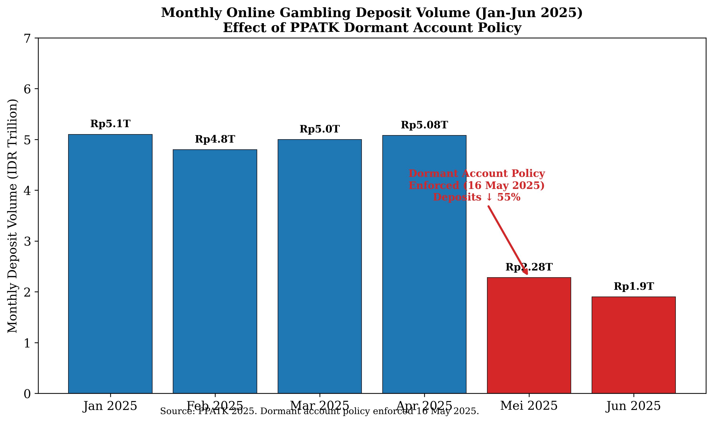
Figure 4. Monthly online gambling deposit volume January-June 2025 with dormant account policy intervention effect.
Source: Processed by authors from PPATK (2025).
The data for the first half of 2025 are particularly striking. In just six months, January to June 2025, total transaction volume reached IDR 287 trillion from 422.1 million individual transactions (PPATK, 2025). This means that the first half of 2025 alone generated nearly 80% of the total transaction value recorded for the entire year of 2024, and the transaction count for these six months - 422.1 million - more than doubled the count for all of 2024 (209.6 million). If the trajectory of the first half of 2025 were to continue linearly through the second half, the full-year 2025 figure would approach IDR 600 trillion, representing a 67% increase over 2024. The compound annual growth rate (CAGR) from 2017 to 2024, calculated conservatively from the annual totals, stands at approximately 100%, indicating a doubling of transaction value approximately every twelve months.
The monthly deposit data for 2025 provide a more granular view of the trend and reveal the impact of regulatory intervention. In January 2025, total monthly deposits amounted to IDR 5.1 trillion. February recorded IDR 4.8 trillion, followed by March at IDR 5.0 trillion. April 2025 marked the peak of the series at IDR 5.08 trillion. Following the implementation of the dormant account policy - which mandated the termination of accounts linked to gambling transactions - in May 2025, deposits fell sharply to IDR 2.28 trillion, a decline of approximately 55% from the April peak. In June 2025, deposits declined further to IDR 1.9 trillion (PPATK, 2025). The pre-policy average of approximately IDR 5.0 trillion per month (January–April) compared with the post-policy average of approximately IDR 2.1 trillion per month (May–June) represents a 58% reduction.
The post-policy figures remain substantial in absolute terms, however. Monthly deposits of IDR 1.9–2.3 trillion are comparable to the annual transaction value for the entire year of 2020 (IDR 94 trillion annualised to IDR 7.8 trillion per month). Even after the most aggressive regulatory intervention in Indonesian history, the monthly gambling deposit volume exceeds the legally recorded annual value for any year prior to 2021. This observation suggests that while the policy produced a dramatic short-term reduction, the underlying demand remains structurally robust, and the post-intervention plateau still represents a level of economic activity that would have been considered extraordinary only four years earlier.

3.2 Demographic Profile of Online Gambling Participants
The demographic characteristics of identified online gambling participants, derived from know-your-customer (KYC) data maintained by financial service providers and reported to PPATK, reveal a strikingly consistent profile. As of May 2025, PPATK recorded 12.3 million active online gambling players in Indonesia (PPATK, 2025). This figure corresponds to a population prevalence rate of approximately 4 to 5 individuals per 100 population, positioning online gambling as a mass participation phenomenon rather than a marginal activity confined to a deviant subpopulation.
The gender distribution is heavily skewed toward male participants, who constitute the overwhelming majority of identified players. This pattern is consistent with international literature documenting higher rates of gambling participation among men across multiple cultural and regulatory contexts (Wardle et al., 2019). The age distribution centres on the prime working-age band of 26 to 45 years, with the modal player falling within the 30–39 age bracket. This age concentration carries particular socioeconomic significance: individuals in this age range are typically at their peak earning potential, are likely to be married with dependent children, and serve as the primary or sole income earners for their households. The concentration of gambling participation in this demographic implies that the financial losses incurred through gambling directly affect not only the individual player but also the dependents who rely on that individual's income.
Marital status data further reinforce this concern. A substantial majority of identified players are recorded as married, meaning that gambling losses are transmitted directly into household units. This pattern distinguishes the Indonesian case from the common Western depiction of problem gambling as a predominantly single-male phenomenon (Langham et al., 2016). The Indonesian data suggest that gambling operates not as an individual vice with individual consequences but as a household-level economic shock with predictable downstream effects on spousal welfare, child development, and family stability.
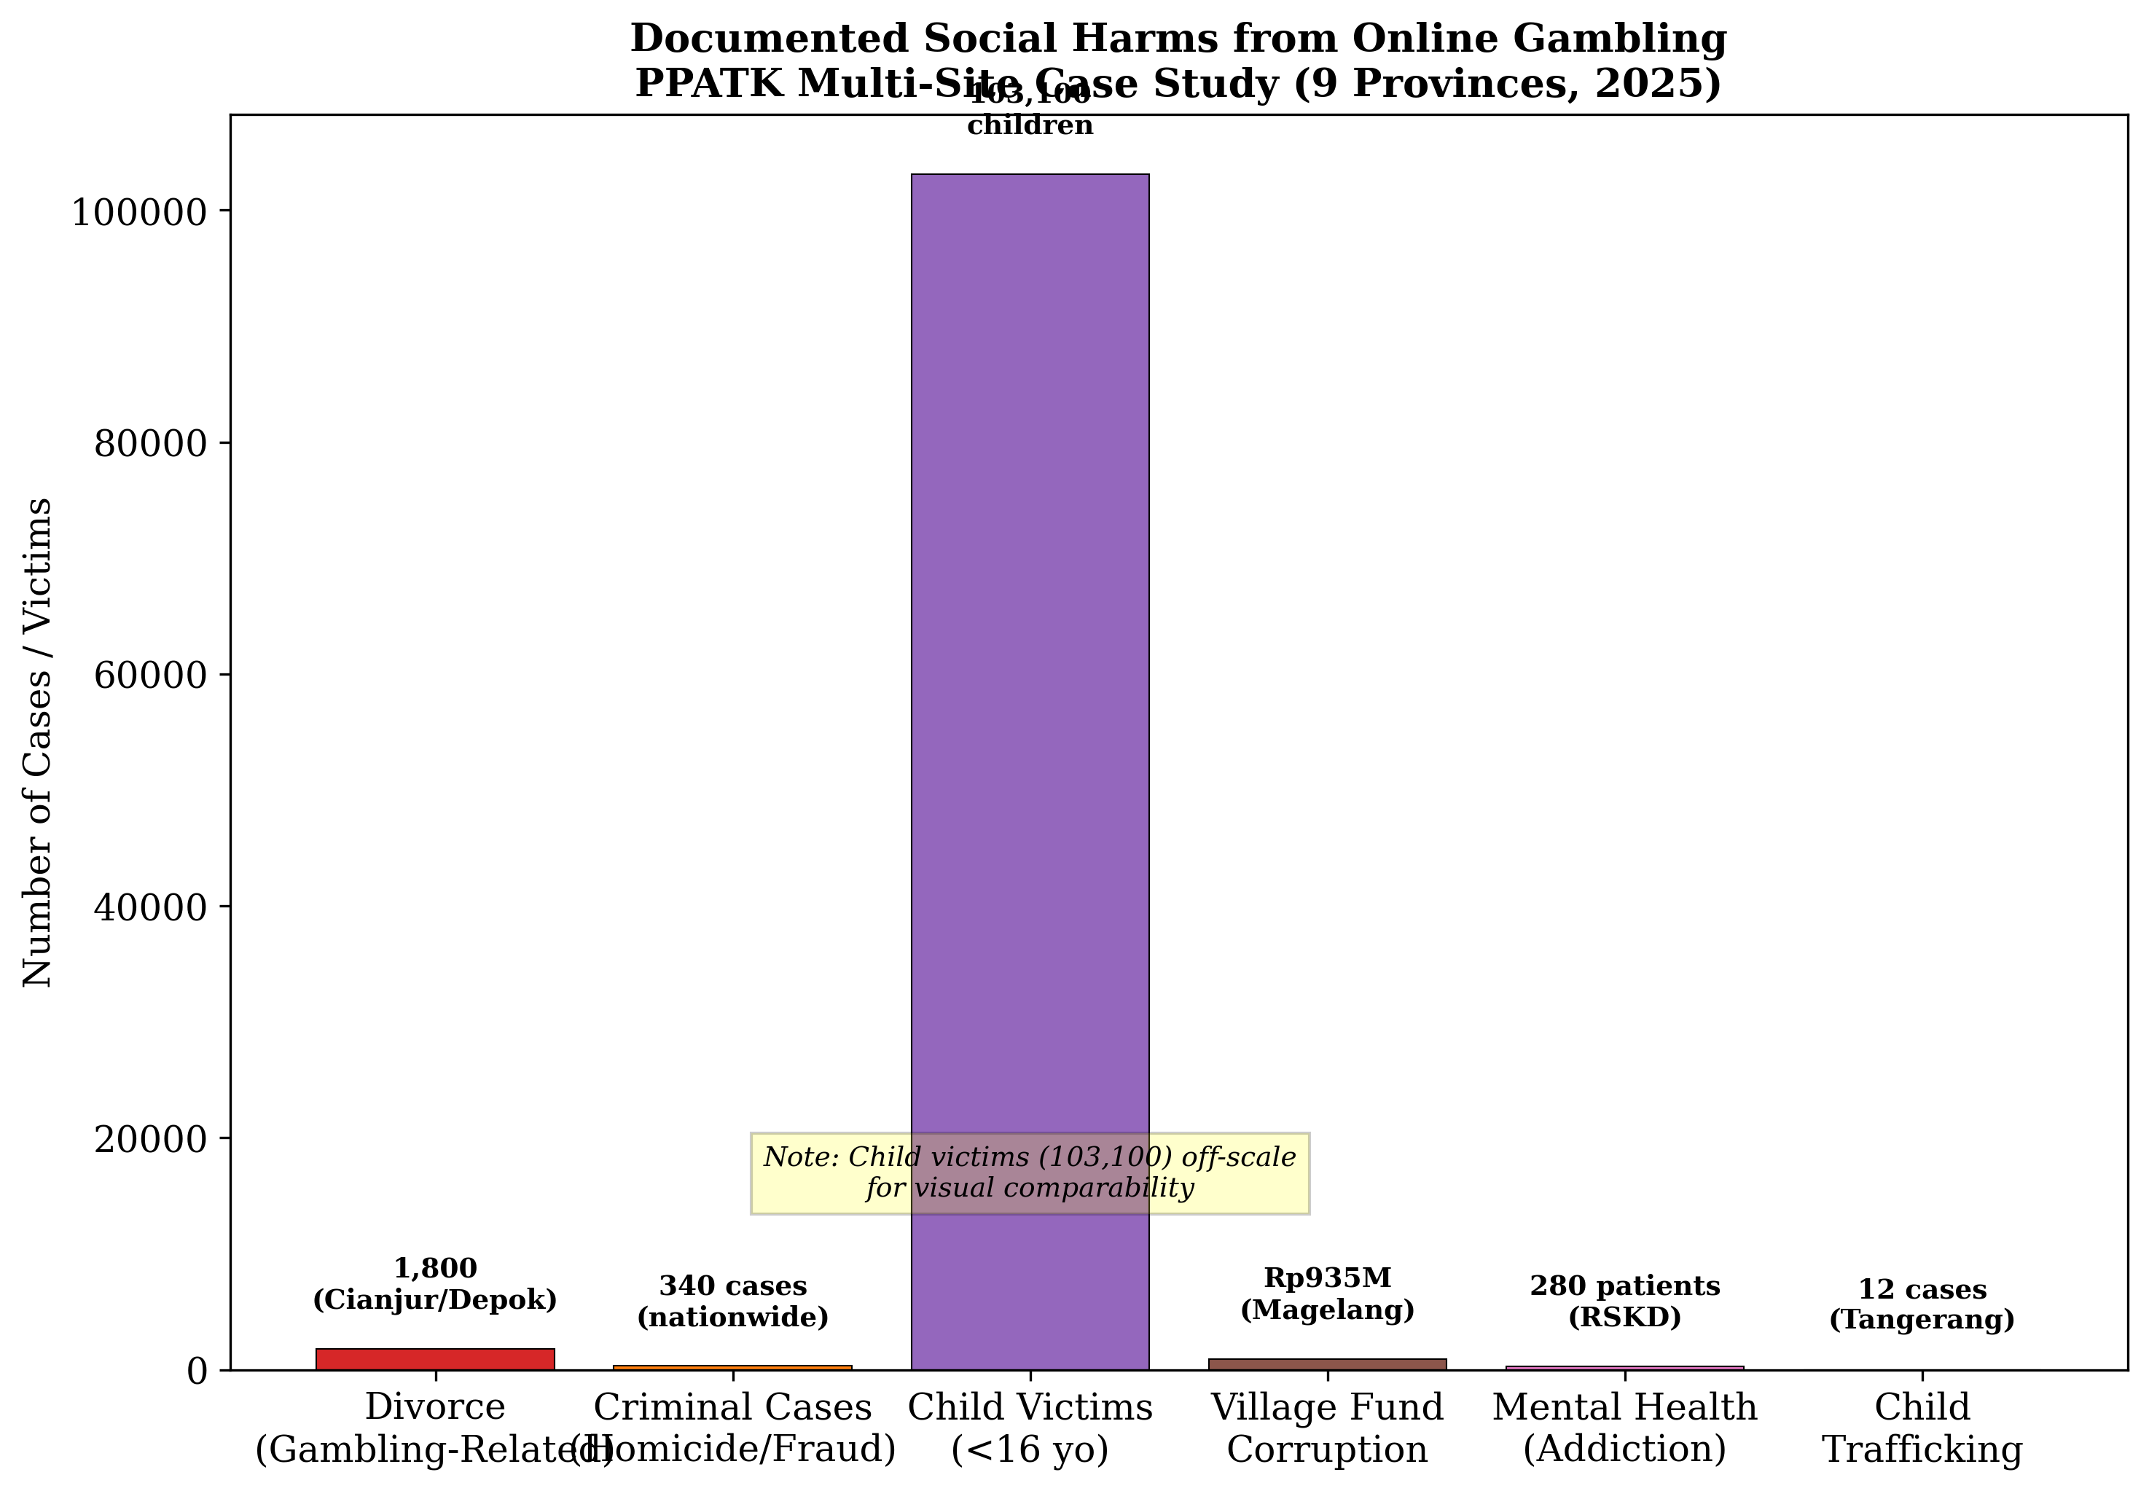
Figure 5. Documented social harms from online gambling across nine Indonesian provinces.
Source: Processed by authors from PPATK (2025).
The income distribution of gambling participants constitutes perhaps the most consequential demographic finding. PPATK (2025) reported that 70.7% of active online gambling players earn less than IDR 5 million per month (approximately USD 315). This figure corresponds to approximately 6.9 million individuals - more than the populations of several Indonesian provinces - whose household incomes place them at or near the national poverty line. The concentration of gambling participation among low-income earners contradicts the intuitive assumption that gambling, as a discretionary leisure activity, would be more prevalent among those with disposable income. Instead, the data reveal a regressive distributional pattern in which those least able to absorb financial losses bear the heaviest burden of gambling expenditure.

3.3 Geography of Harm: Spatial Distribution of Gambling Prevalence
The spatial analysis of PPATK data reveals a concentrated geography of online gambling harm, with prevalence rates varying substantially across Indonesia's provinces and cities. At the provincial level, DKI Jakarta recorded the highest prevalence rate at 6.8% of the population, followed by Banten (5.9%), Jawa Barat (West Java, 5.4%), Bali (4.8%), and Jawa Tengah (Central Java, 4.5%) (PPATK, 2025). These five provinces, all located on the island of Java excepting Bali, form a contiguous high-prevalence belt across western and central Indonesia's most densely populated regions.
The city-level data provide even finer-grained spatial resolution. Among the top ten cities with the highest prevalence rates of online gambling participation, four are located within DKI Jakarta (Jakarta Pusat, Jakarta Selatan, Jakarta Barat, and Jakarta Timur), four are in Jawa Barat (Kota Bekasi, Kota Depok, Kota Bogor, and Kota Bandung), and two are in Banten (Kota Tangerang and Kota Tangerang Selatan) (PPATK, 2025). The Jabodetabek megalopolitan region - encompassing Jakarta, Bogor, Depok, Tangerang, and Bekasi - thus constitutes the dominant cluster of online gambling activity in Indonesia, accounting for eight of the ten highest-prevalence cities. This spatial pattern suggests that online gambling penetration is most intense in areas characterised by high population density, extensive digital infrastructure (particularly mobile internet penetration), and concentrated poverty in proximity to wealth.
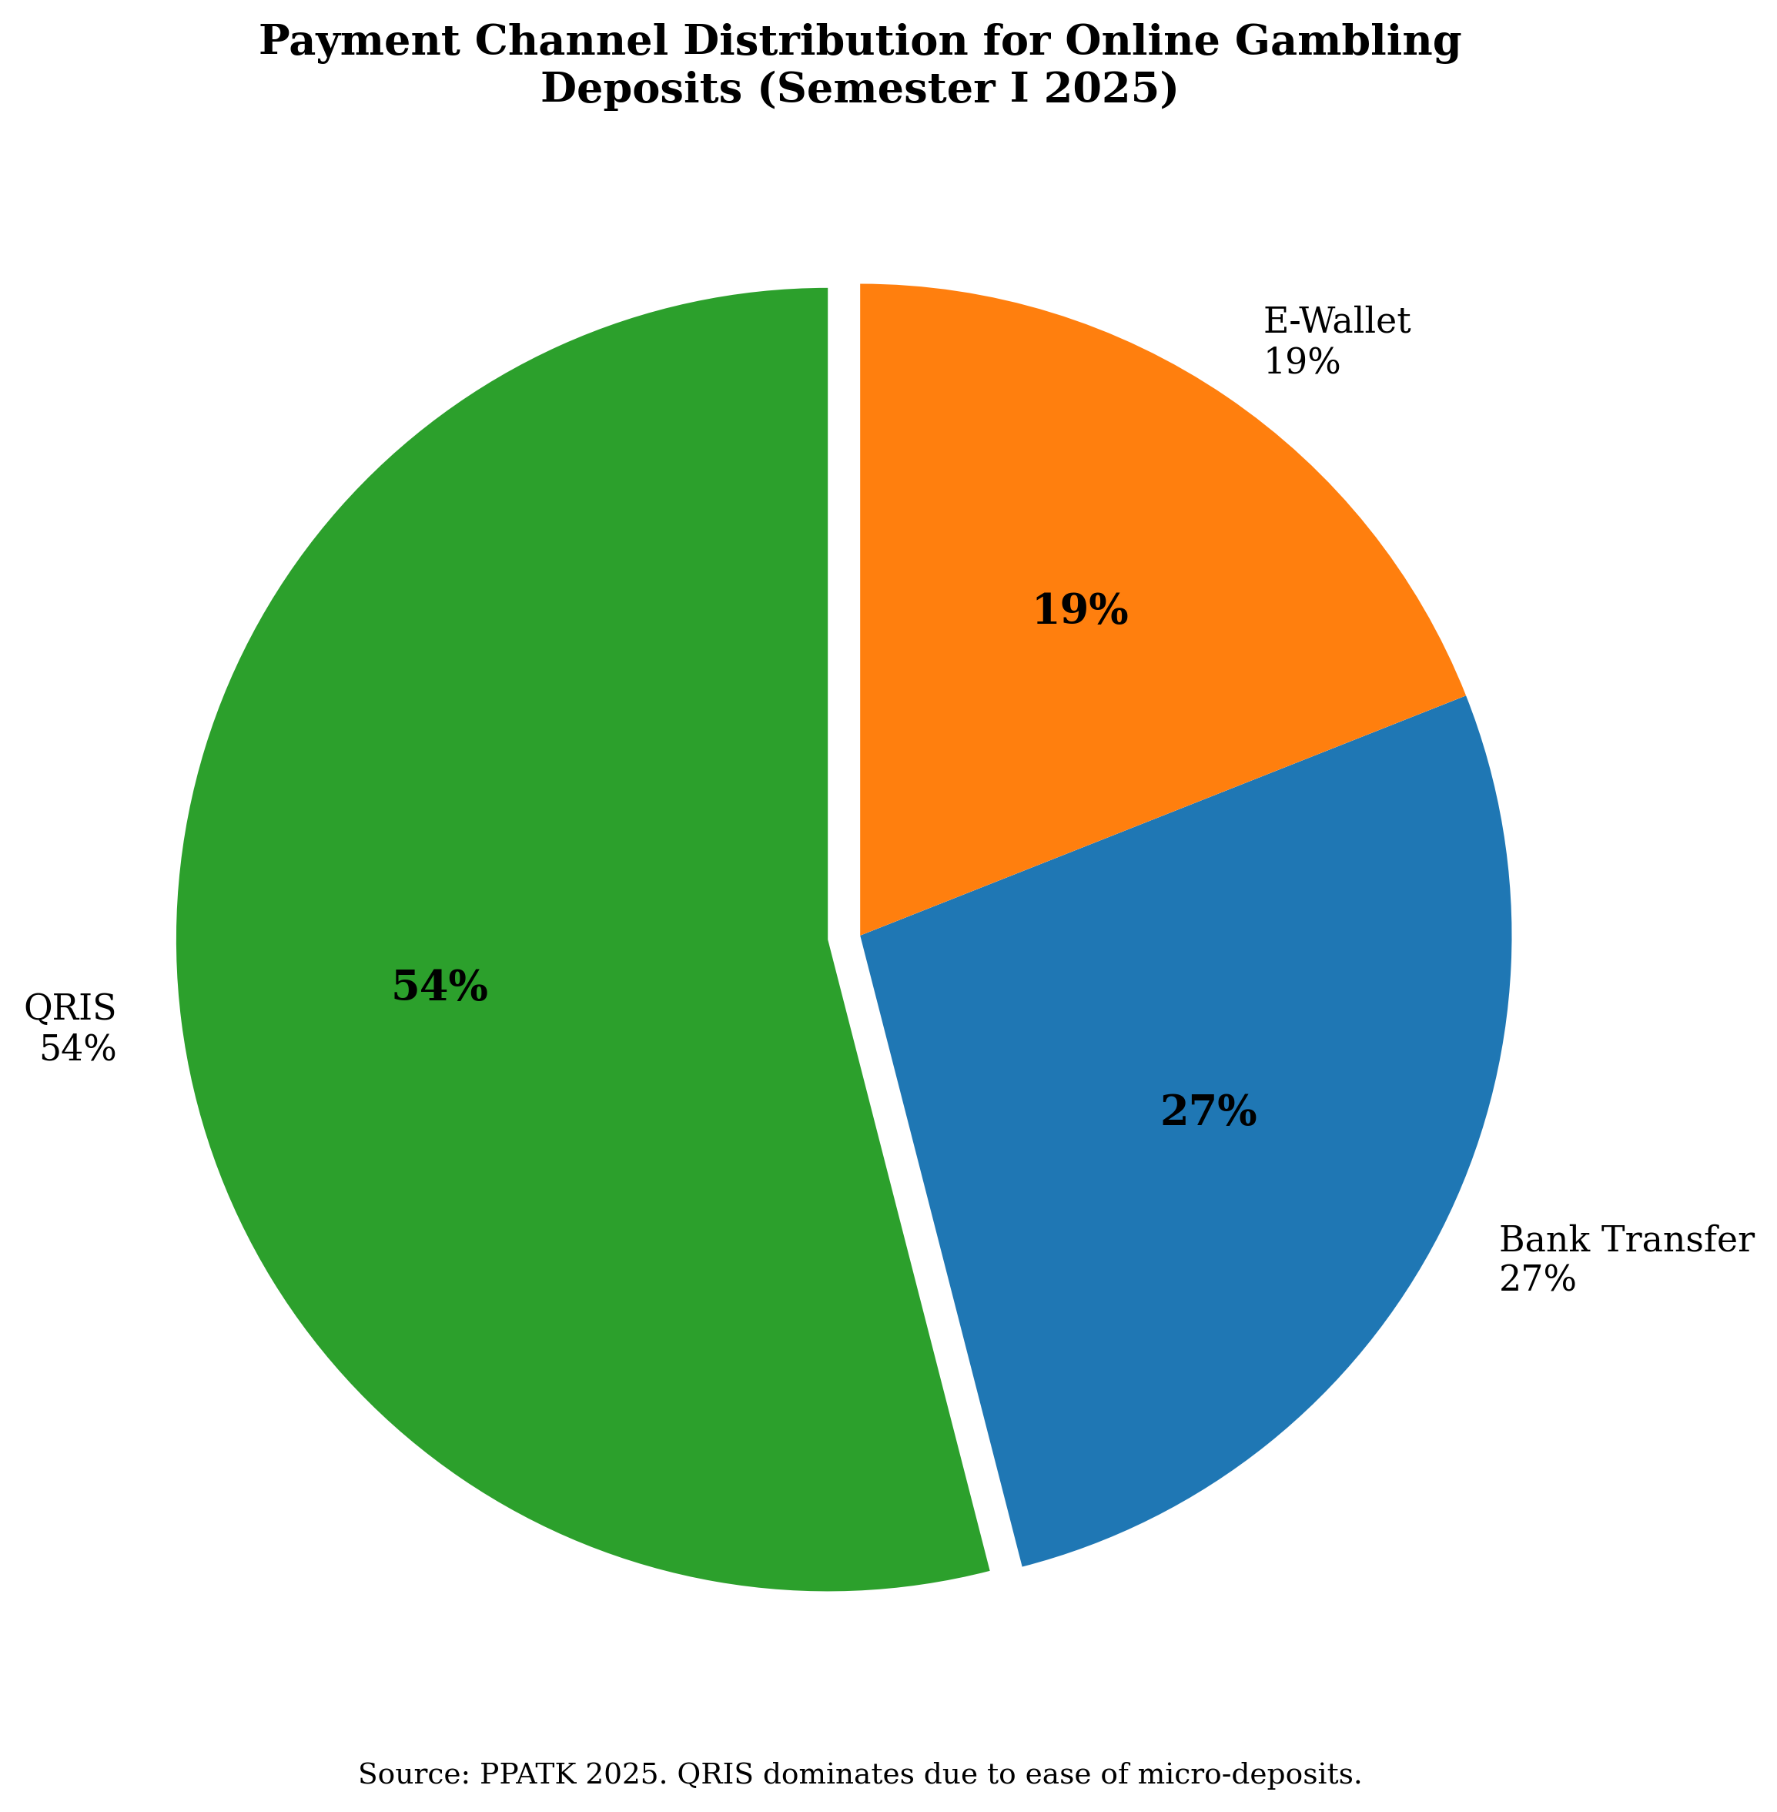
Figure 6. Payment channel distribution for online gambling deposits (QRIS accounts for 54% of transactions).
Source: Processed by authors from PPATK (2025).
The case of Cengkareng district in West Jakarta merits particular attention. PPATK (2025) identified 14,000 active online gambling players in Cengkareng out of a total population of approximately 56,000, yielding a district-level prevalence rate of 25% - five times the national average and among the highest documented rates for any administrative unit in Indonesia. While the precise mechanisms driving this extreme concentration require further investigation, the Cengkareng case illustrates the potential for online gambling to achieve near-ubiquitous penetration in specific localities, with correspondingly devastating effects on household economies and social cohesion.

3.4 The Poverty Tax: Regressive Economic Burden of Gambling
The convergence of demographic and financial data reveals a regressive economic mechanism that we term the "poverty tax" - the disproportionate extraction of resources from low-income populations through gambling expenditure. With 70.7% of players (approximately 6.9 million individuals) earning less than IDR 5 million per month, and with aggregate monthly deposits averaging approximately IDR 5 trillion in the pre-policy period, the implied average monthly gambling expenditure per low-income player is substantial. If the total monthly deposit figure of IDR 5 trillion is distributed across the 12.3 million active players, the mean monthly expenditure per player is approximately IDR 406,000 (approximately USD 26). For the 6.9 million low-income players earning less than IDR 5 million, this mean expenditure represents at least 8.1% of monthly income - a proportion that, by any standard, constitutes a severe drain on household resources.
The welfare implications of this expenditure pattern are profound. At 8.1% of income, gambling expenditure among low-income players exceeds the proportion of income that Indonesian households typically allocate to education (approximately 3–4%) and rivals the proportion allocated to healthcare (PPATK, 2025). This displacement of expenditure from basic needs to gambling represents a direct transfer of resources from household welfare to the gambling ecosystem. The economic logic of this transfer is regressive in its distributional impact: the poor pay a larger share of their income into a system that, by design, returns less value to participants than it extracts.
The poverty tax mechanism is reinforced by the psychological dynamics of gambling among low-income populations. Interviews with financial intelligence analysts (Interview FI-04, 2025) and social workers (Interview SW-07, 2025) indicated that gambling is frequently perceived by low-income players as a rational response to economic precarity - a means of escaping poverty through a single lucky bet rather than through the slow and uncertain accumulation of wages. This "lottery mentality," as one informant termed it, is systematically cultivated by gambling platforms through marketing messages that emphasise rapid wealth accumulation and through the design of near-miss outcomes that sustain the illusion of imminent success. The combination of structural economic vulnerability and platform-designed exploitation creates a poverty trap in which gambling losses deepen the very precarity that motivates participation.

3.5 Children as Victims: Minor Participation in the Gambling Ecosystem
One of the most alarming findings to emerge from the PPATK data is the documented participation of minors in online gambling. PPATK (2025) identified 103,100 active online gambling players under the age of 16, disaggregated into 36,400 children under the age of 11 and 66,700 adolescents aged 11 to 16 years. These figures are drawn from KYC records maintained by financial service providers and therefore represent a lower-bound estimate; the true number of minors participating in online gambling is likely substantially higher, given that many children use parental identities, shared family accounts, or unofficially registered prepaid mobile accounts that do not trigger KYC age verification.
The presence of 36,400 children under 11 years old - primary school-aged children - in an activity designed for adult participation is a stark indicator of the failure of existing age-verification mechanisms in Indonesia's digital payment ecosystem. Under Indonesian law, children below the age of 17 cannot legally enter into contracts, including the terms-of-service agreements required to open a bank account or e-wallet. Yet the transaction data demonstrate that these legal barriers are routinely bypassed, either through parental facilitation (parents allowing or enabling children to use their accounts), platform indifference (gambling sites that do not verify age at registration), or payment intermediaries that do not enforce KYC standards for low-value transactions.
The clinical consequences of early exposure to gambling are well documented in the international literature. The World Health Organization's classification of gambling disorder as an addictive behaviour in ICD-11 (WHO, 2019) is premised on evidence that gambling activates the same neural reward pathways as substance use disorders, and that early exposure to variable-ratio reinforcement schedules - the core psychological mechanism of gambling - is associated with accelerated progression to problem gambling (Gainsbury, 2015). The Indonesian data thus point to a cohort of over 100,000 children who are being exposed to a potentially addictive behaviour during critical developmental windows, with implications for their lifelong risk of gambling disorder, financial literacy, and impulse regulation.
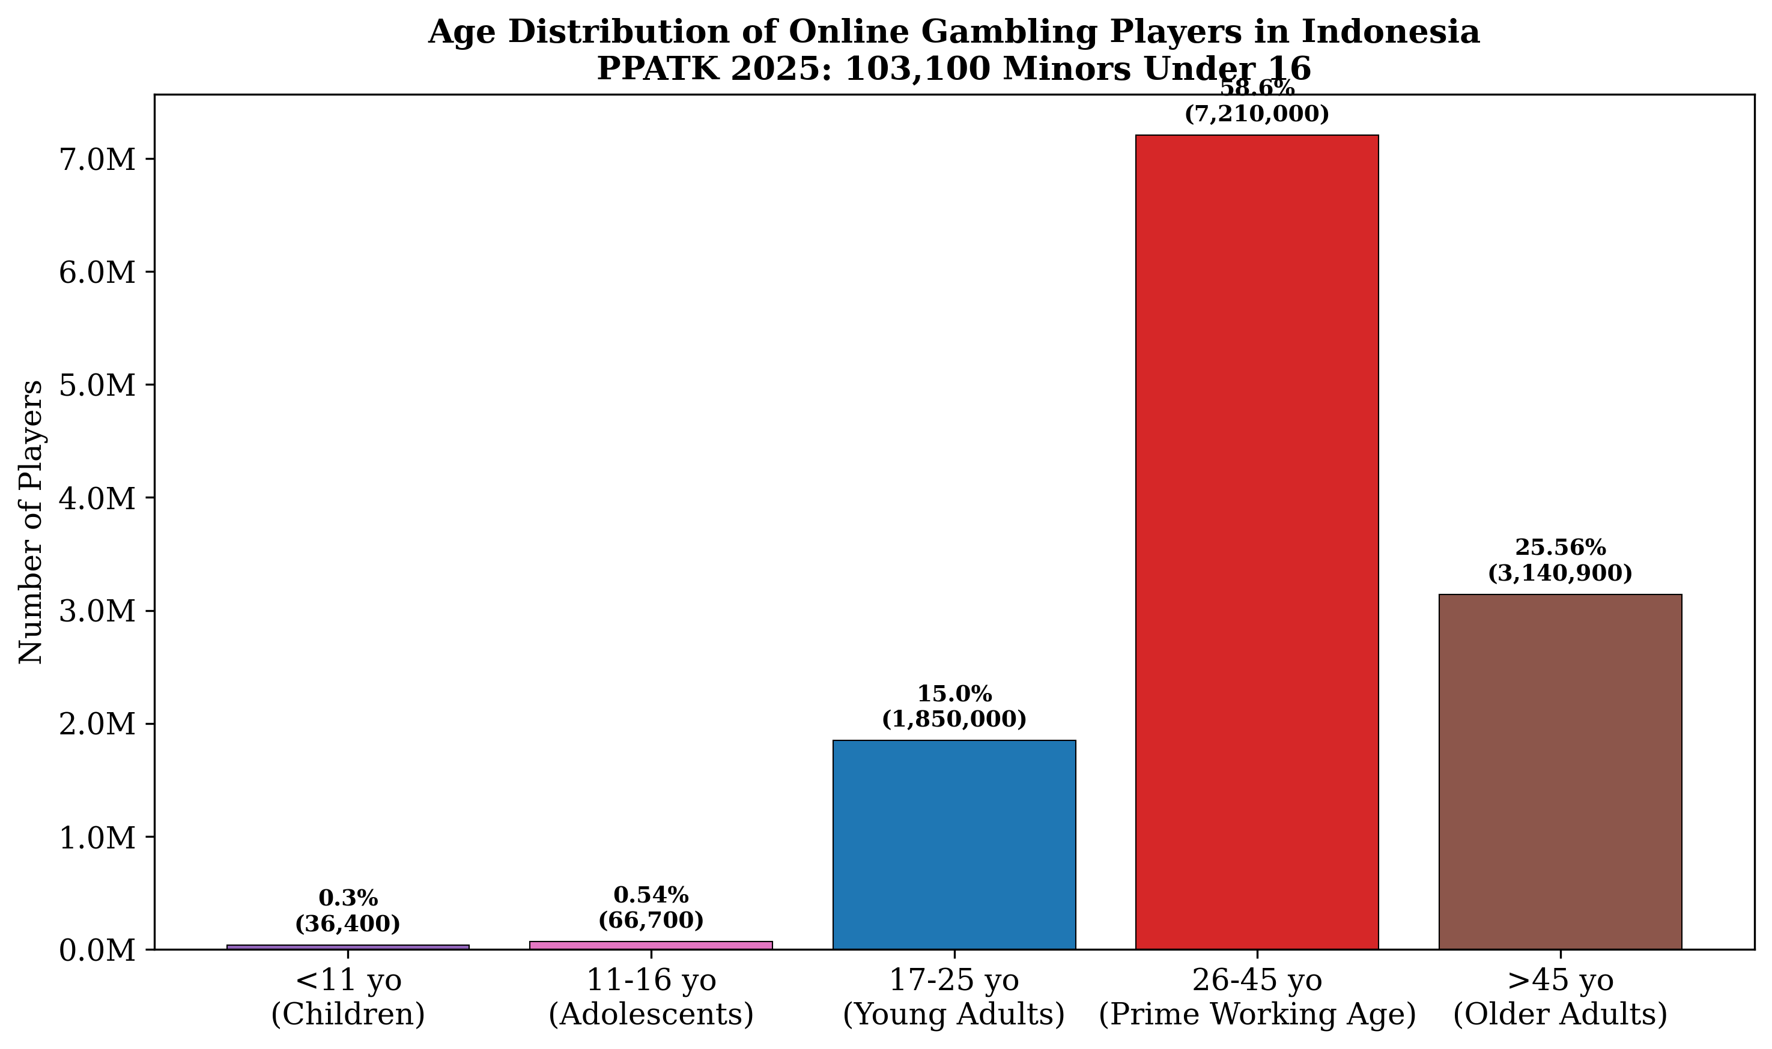
Figure 7. Age distribution of online gambling players including 103,100 minors under 16 years old.
Source: Processed by authors from PPATK (2025).
The qualitative data from key informants provide additional context. A Religious Court judge in Yogyakarta (Interview RCJ-03, 2025) observed that education level is not a protective factor against gambling addiction, noting that even university students appeared before the court in gambling-linked divorce cases. This observation aligns with the quantitative pattern: gambling penetration extends across educational strata, and the mechanisms of platform addiction operate independently of cognitive sophistication. The judge further noted that many young adults who began gambling as minors described their initial exposure as occurring through online game advertisements that redirected to gambling sites - a pattern consistent with the "gateway" hypothesis in which non-gambling digital entertainment introduces users to gambling mechanics.

3.6 The Social Destruction Cascade
The aggregate financial and demographic data, while establishing the scale and distribution of online gambling participation, cannot in themselves capture the mechanisms through which gambling transactions translate into human suffering. The qualitative component of this study, drawing on judicial records, administrative data, and interview testimony from nine provinces, documents a cascade of social destruction that spans the domestic, economic, criminal, and institutional domains. We present six sub-cases that illustrate the range and severity of gambling-related harm.

3.6.1 Family Dissolution: The Religious Courts Evidence
The most extensively documented domain of gambling-related social harm is family dissolution. Indonesia's Religious Courts (Pengadilan Agama) handle all family law matters for Muslim citizens, including divorce petitions, and several courts have begun systematically recording whether gambling is cited as a causal factor in divorce filings. The data from three courts provide convergent evidence of a strong association.
At the Cianjur Religious Court (Pengadilan Agama Cianjur) in Jawa Barat, 1,800 out of 2,373 divorce cases handled during the observation period were directly linked to online gambling addiction (PPATK, 2025). This proportion - 75.8% - indicates that gambling operated as the dominant rather than incidental factor in marital dissolution within this jurisdiction. The court's registry records noted that in a substantial proportion of these cases, wives filed for divorce citing husbands' gambling addiction as the primary cause, often accompanied by secondary factors such as domestic violence, financial neglect, and the sale of household assets.
At the Depok Religious Court, located in the high-prevalence Jabodetabek cluster, 70% of 1,133 divorce cases were linked to both online gambling and online loans (pinjaman online, or Pinjol) (PPATK, 2025). The Depok data reveal an important nexus between gambling and consumer credit: many gambling-addicted husbands had accumulated unmanageable debts through online loan applications, with debt collectors harassing wives and family members. In cases where wives were co-signatories to online loans - a common practice in Indonesian household credit arrangements - the women bore legal liability for gambling debts they had neither incurred nor consented to.
At the Bojonegoro Religious Court in Jawa Timur, 170 divorce filings explicitly named gambling as the primary cause of marital breakdown in the period January to April 2024 alone (PPATK, 2025). This figure represented approximately 17.5% of the 971 total divorce cases filed during that period. While the proportion is lower than in Cianjur, the Bojonegoro data capture a rapidly accelerating trend: court officials reported that gambling-related filings had been negligible prior to 2022 and had increased dramatically in the subsequent two years, mirroring the national trajectory of transaction growth.
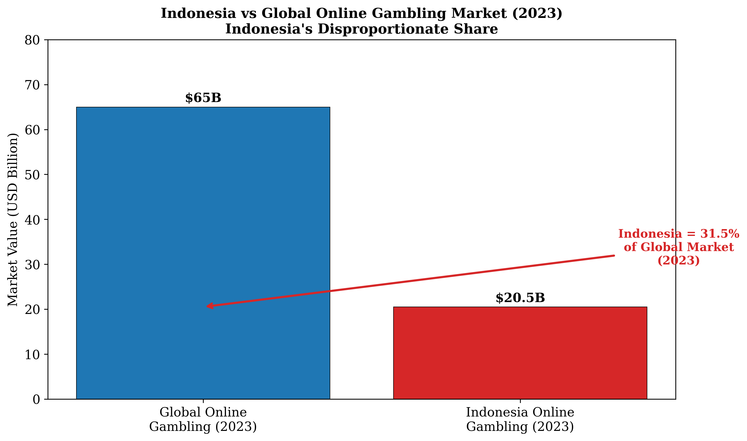
Figure 8. Indonesia vs global online gambling market value: approximately 31.5% of the global market (2023).
Source: Processed by authors from PPATK (2025).

3.6.2 Village Fund Embezzlement in Magelang
The case of a village head in Magelang, Central Java, illustrates the penetration of gambling addiction into the institutions of local governance. The village head was found to have embezzled IDR 935 million (approximately USD 59,000) of village development funds over a period of approximately eighteen months to finance an online gambling habit (PPATK, 2025). The modus operandi involved the systematic diversion of funds allocated for infrastructure projects - including road repairs, irrigation systems, and village health facilities - into personal accounts that were then used for gambling deposits. When the funds were depleted, the village head sold village-owned assets, including livestock (cows) and equipment, to continue gambling.
This case is significant not only for the magnitude of the embezzlement - IDR 935 million represents a substantial fraction of the annual village development budget for a small rural community - but for what it reveals about the mechanisms of gambling-related corruption. The village head was not a pre-existing corrupt official who happened to gamble; rather, court testimony and investigative records indicated that the gambling addiction preceded and caused the corruption. The official's salary was insufficient to sustain a gambling habit of escalating intensity, and the embezzlement was a direct consequence of the addiction's demand for ever-increasing stakes. The case thus demonstrates a causal pathway from gambling participation to corruption: addiction creates financial pressure that overrides ethical constraints, particularly in contexts where institutional oversight is weak and access to public funds is relatively easy.

3.6.3 Homicide in Halmahera: Gambling-Induced Violence
The convergence of gambling addiction and violent crime is starkly illustrated by the case of a civil servant employed by the Badan Pusat Statistik (BPS) in Halmahera, North Maluku. The employee, identified as AH in court records, lost IDR 130 million (approximately USD 8,200) in a single night of online gambling (PPATK, 2025). Following the loss, AH fatally stabbed a coworker during an altercation that, according to investigative reports, was precipitated by the psychological distress of the gambling loss.
This case represents an extreme but not isolated instance of gambling-induced violence. The psychological literature on gambling disorder documents elevated rates of irritability, aggression, and impulse dyscontrol among problem gamblers, particularly in the period immediately following significant losses (Muggleton et al., 2021). The Halmahera case exemplifies how the acute financial and psychological pressure of a catastrophic loss can trigger violence with lethal consequences. It further illustrates the risk that gambling addiction poses not only to the gambler and his immediate family but to innocent third parties - in this case, a coworker with no involvement in the gambling activity.

3.6.4 Child Selling in Tangerang
Perhaps the most extreme documented case of gambling-related family dysfunction involved a father in Tangerang, Banten, who sold his biological child to obtain cash for a gambling deposit (PPATK, 2025). The case, which resulted in criminal prosecution and a prison sentence, represents the complete collapse of the parental protection function under the pressure of gambling addiction. The father had reportedly exhausted all other sources of funds - personal savings, salary, loans from relatives, and informal credit - before resorting to the sale of his child.
This case, while extreme in its specifics, indexes a broader pattern of child welfare violations associated with gambling. In less dramatic form, social workers interviewed for this study (Interview SW-04, SW-09, 2025) reported cases of children being left unsupervised while parents gambled, children being deprived of food and school fees because household income was diverted to gambling, and children being exposed to domestic violence precipitated by gambling losses. The Tangerang case represents the terminal point of a continuum of child neglect that begins with reduced household expenditure on children and escalates, in the most severe instances, to the commodification of the child as a financial asset to be liquidated for gambling.

3.6.5 The Failure of Educational Protection
A consistent finding across the qualitative data is that educational attainment does not function as a protective factor against gambling addiction. A Religious Court judge in Yogyakarta - a city with one of the highest concentrations of universities and tertiary education institutions in Indonesia - observed that university students, lecturers, and even individuals with postgraduate degrees appeared in court as respondents in gambling-linked divorce cases (Interview RCJ-03, 2025). This observation challenges the assumption that education equips individuals with the critical thinking skills necessary to resist gambling's appeal.
The mechanisms underlying this pattern are twofold. First, the psychological design of online gambling platforms - variable-ratio reinforcement schedules, near-miss effects, and loss-chasing affordances - operates at a pre-cognitive level that is largely impervious to rational evaluation (Brown, 2021). Educated gamblers are no less susceptible to the dopamine-driven conditioning effects of intermittent rewards than uneducated gamblers; indeed, educated gamblers may be more vulnerable to the overconfidence bias that leads them to believe they can "beat the system" through superior analysis of odds or betting strategies. Second, the pervasive marketing of online gambling through digital channels - social media advertisements, influencer endorsements, and embedded links in non-gambling content - ensures that educational status confers no immunity to exposure. The Yogyakarta data thus reinforce a finding with significant policy implications: interventions that rely on information provision or educational campaigns alone are unlikely to be effective against a harm architecture that operates below the threshold of rational decision-making.

3.6.6 Clinical Equivalence to Narcotics Addiction
Medical professionals at the Rumah Sakit Ketergantungan Obat (RSKD), Indonesia's national drug addiction hospital, have drawn a direct clinical equivalence between online gambling addiction and narcotics addiction (PPATK, 2025). Patients presenting with gambling disorder at RSKD exhibit symptom profiles - including tolerance (the need to gamble with increasing amounts to achieve the desired excitement), withdrawal (irritability, anxiety, and depression when unable to gamble), loss of control, and continued use despite negative consequences - that meet the diagnostic criteria for substance use disorders as defined in DSM-5 and ICD-11. The clinical protocols employed at RSKD for gambling addiction mirror those used for substance addiction, including cognitive-behavioural therapy, pharmacological intervention for comorbid conditions, and residential treatment programmes.
The RSKD equivalence carries significant implications for Indonesia's public health response to online gambling. If gambling addiction is clinically indistinguishable from narcotics addiction in its symptom profile, severity, and treatment requirements, then the scale of the gambling crisis - with 12.3 million active players - implies a demand for addiction treatment services that far exceeds Indonesia's current capacity. The three RSKD facilities nationwide, with a combined capacity of fewer than 500 inpatient beds, are manifestly inadequate to address a population with over 100,000 minor participants alone, let alone the millions of adults who may meet clinical criteria for gambling disorder.

3.7 Policy Effectiveness: The Dormant Account Intervention
The most significant regulatory intervention in the Indonesian online gambling landscape occurred in April–May 2025, when PPATK, in coordination with the Financial Services Authority (OJK) and Bank Indonesia, mandated that financial service providers terminate accounts identified as being used for gambling transactions. This "dormant account policy" required banks, e-wallet operators, and payment gateways to freeze and eventually close accounts that had been linked to gambling deposits or withdrawals, with funds held pending verification of legitimate ownership.
The impact of this policy on transaction volumes was immediate and substantial. As detailed in Section 3.1, monthly deposit values declined from a pre-policy average of approximately IDR 5.0 trillion (January–April 2025) to IDR 2.28 trillion in May and IDR 1.9 trillion in June 2025 - a reduction of approximately 55–62%. The effect on transaction frequency was even more pronounced: the number of transactions per month fell by approximately 78% in the immediate post-policy period (PPATK, 2025).
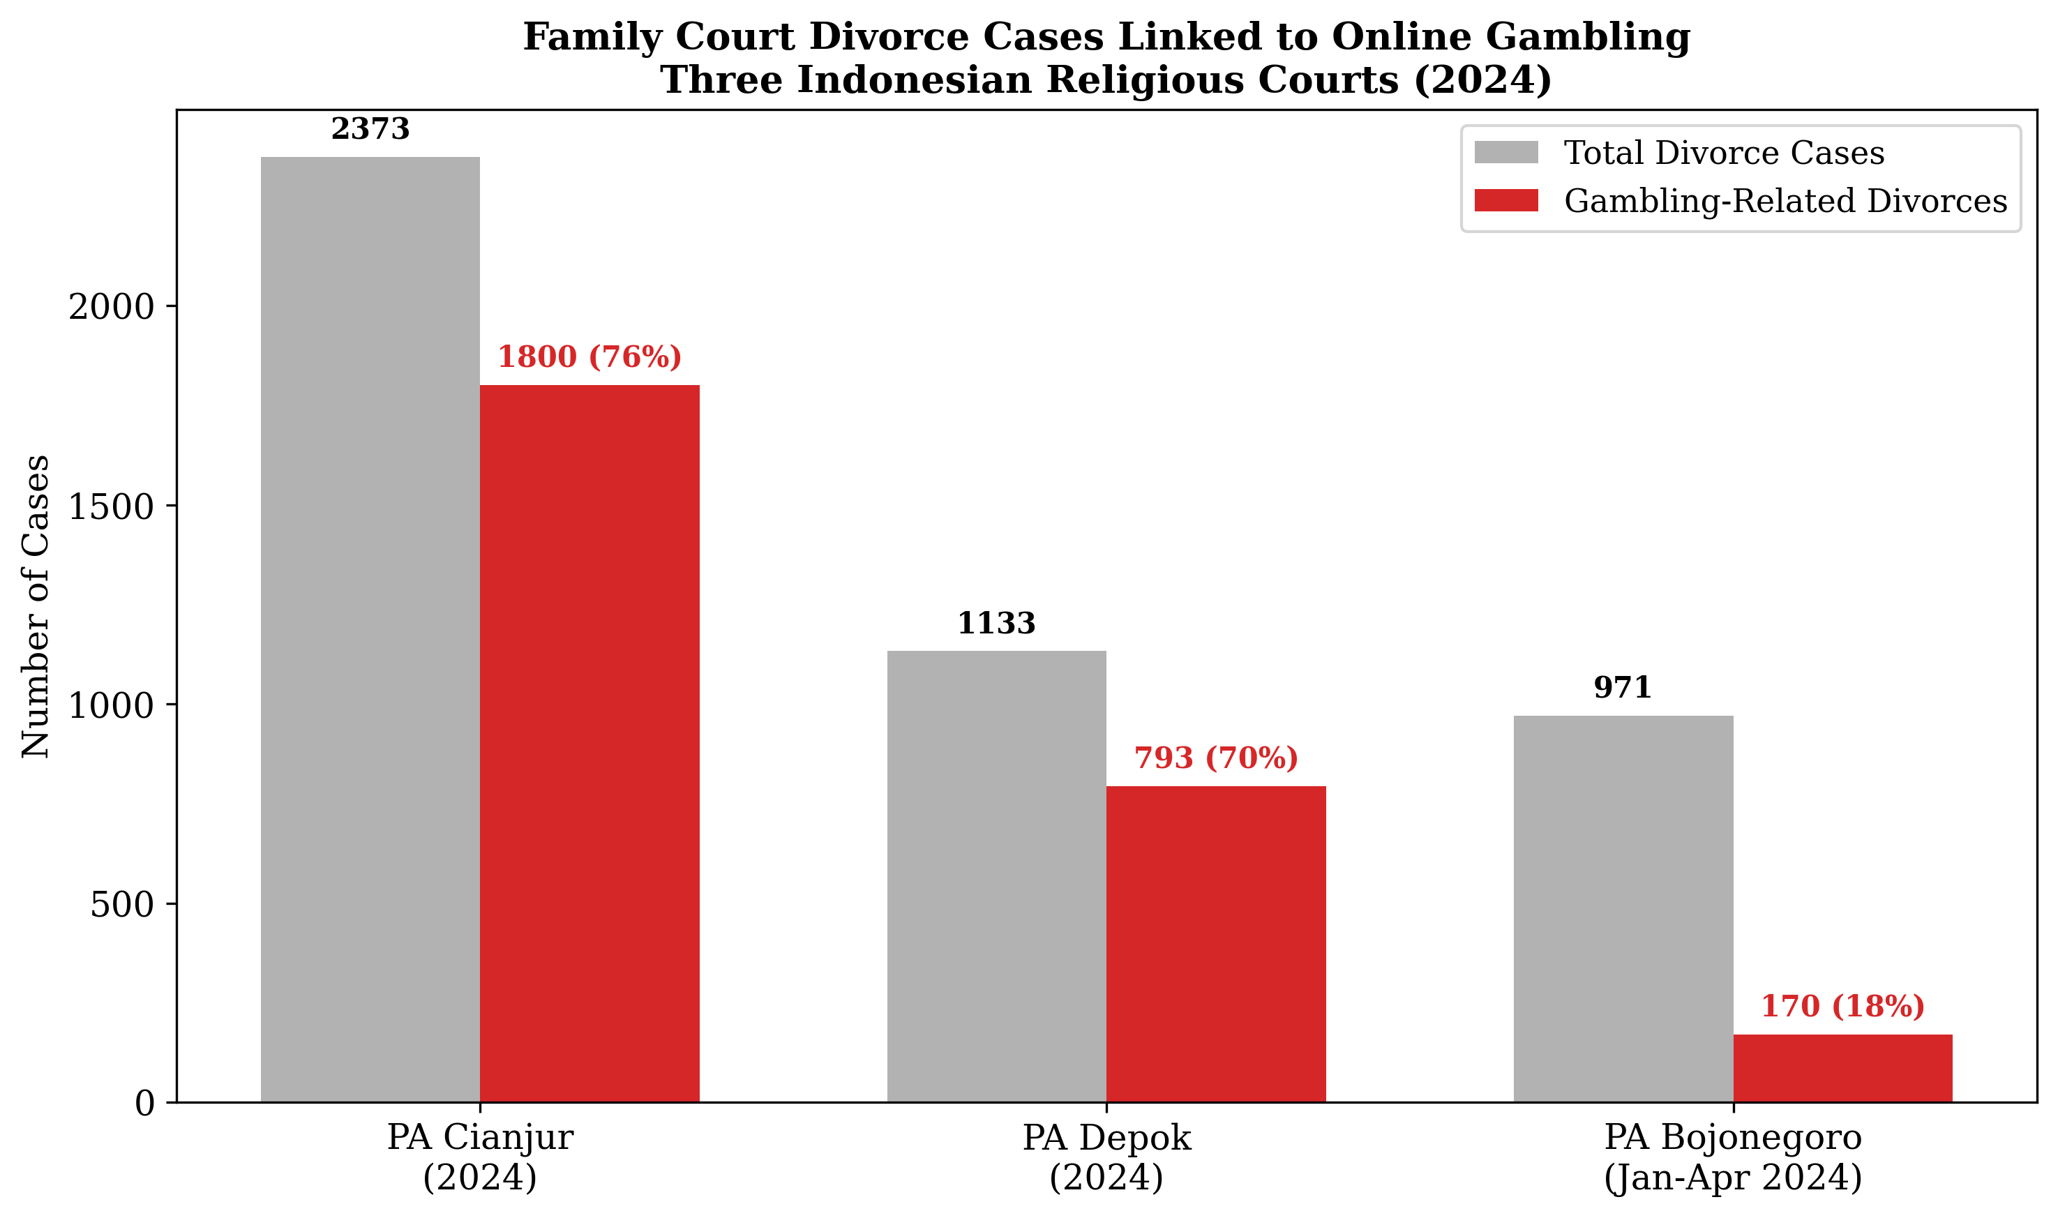
Figure 9. Gambling-linked divorce cases in three Indonesian Religious Courts, 2024.
Source: Processed by authors from PPATK (2025).
These results suggest that supply-side financial intervention can produce meaningful short-term disruption of the gambling ecosystem. The dormant account policy targets the payment infrastructure on which the gambling industry depends, making it more difficult for players to deposit funds and for operators to receive payments. The mechanism of action is different from website blocking, which targets the gambling platform itself but can be circumvented through domain mirroring, virtual private networks, and alternative access methods. By contrast, account termination targets the player's access to the financial system - a bottleneck that is harder to bypass without resorting to entirely informal payment channels.
However, several caveats must be noted. First, the policy effect may be confounded by seasonal variation, simultaneous law enforcement operations, or supply-side disruptions unrelated to the account termination policy. The absence of a counterfactual control group precludes causal attribution with certainty. Second, the policy may induce displacement effects: players whose bank accounts or e-wallets are terminated may migrate to alternative payment channels - including cryptocurrency, peer-to-peer transfers, or cash agents - that are not covered by the policy. The relative stability of the June figure (IDR 1.9 trillion compared with IDR 2.28 trillion in May) suggests that the initial sharp decline may have been partially offset as players adapted to the new regulatory environment. Third, the policy imposes costs on legitimate account holders whose accounts are frozen erroneously due to false positives in the transaction screening algorithms, raising due process concerns that have been raised by civil society organisations.
3.8 Financial Infrastructure: Payment Channels and the Gambling Ecosystem
The analysis of payment channel data reveals the critical role of digital financial infrastructure in enabling online gambling. PPATK (2025) data on payment channel usage show that Quick Response Code Indonesian Standard (QRIS) accounted for 54% of all gambling-related transactions, making it the dominant payment modality. Bank transfers accounted for 27%, while electronic wallets (e-wallets) accounted for 19%.
The dominance of QRIS as a gambling payment channel is a particularly significant finding. QRIS was introduced by Bank Indonesia in 2019 as a unified payment standard designed to promote financial inclusion by enabling merchants to accept payments from any QRIS-compatible application. Its adoption has been rapid, with over 30 million merchants and 200 million users by early 2025. However, the same features that make QRIS attractive for legitimate commerce - low transaction costs, instant settlement, interoperability across platforms, and minimal friction for users - also make it attractive for gambling transactions. Gambling operators accept QRIS payments by registering as "merchants" with payment gateway providers, often using shell business identities or misrepresenting their business category. The user scans a QR code displayed on the gambling platform, and funds are transferred from the user's e-wallet or bank account to the operator's merchant account within seconds.
The concentration of gambling payments in QRIS (54%) has important implications for regulatory strategy. Interventions that target QRIS - such as enhanced merchant due diligence by payment gateway providers, mandatory business category verification, and real-time transaction monitoring for gambling-related patterns - could potentially disrupt the majority of gambling payment flows. The dormant account policy described in Section 3.7 represents one such intervention, but more targeted measures directed at the QRIS ecosystem specifically could yield additional gains.
Bank transfers (27%) and e-wallets (19%) represent secondary but still substantial channels. Unlike QRIS, which involves a merchant-acquirer relationship, peer-to-peer bank transfers and e-wallet transfers do not require a merchant registration, making them harder to intercept through merchant due diligence. These channels are more likely to be used by experienced gamblers who have established direct relationships with operators or agents, bypassing the formal merchant payment infrastructure.

3.9 The Pinjol-Judol Nexus: Online Gambling and Predatory Lending
A cross-cutting finding that emerged from both the quantitative and qualitative data is the systematic interconnection between online gambling (judi online, Judol) and online loans (pinjaman online, Pinjol). This nexus represents a two-tiered extraction mechanism: the gambling platform extracts funds from the player through the inherent house edge and variable-ratio reinforcement schedule, while the online loan platform extracts additional funds through usurious interest rates, hidden fees, and aggressive debt collection practices.
The quantitative dimension of this nexus is difficult to measure directly, as PPATK data do not systematically cross-reference gambling transactions with loan origination. However, the Depok Religious Court data provided an important indicator: 70% of divorce cases linked to gambling also involved Pinjol debts (PPATK, 2025). This co-occurrence rate suggests that borrowing to gamble is not a marginal practice but a routine component of the gambling behaviour of married men in this jurisdiction.
The mechanisms of the Pinjol-Judol nexus operate at two levels. At the individual level, players who deplete their disposable income through gambling losses turn to online loan applications to replenish their gambling funds, a phenomenon known in the addiction literature as "chasing losses" (Langham et al., 2016). The instant disbursement, minimal documentation requirements, and high credit limits of many Pinjol applications make them ideal instruments for loss chasing. As gambling losses mount, players take out multiple loans from different applications, creating a debt spiral in which each loan is used to service the interest on previous loans while new gambling losses accumulate.
At the systemic level, the Pinjol-Judol nexus is supported by overlapping digital infrastructure, shared marketing channels, and in some cases common ownership. Key informants from PPATK (Interview FI-04, 2025) indicated that certain online loan platforms have been identified as routing customer funds directly to gambling operators, effectively functioning as gambling payment intermediaries. Conversely, gambling operators have been found to offer in-platform credit or referral arrangements with loan applications, creating a closed loop in which gambling losses generate demand for loans, and loan repayments supply the funds for further gambling.
The social consequences of the Pinjol-Judol nexus extend beyond the individual gambler to encompass his social network. Online loan applications typically require access to the borrower's contact list, and default triggers automated harassment of family members, friends, and colleagues through text messages and phone calls. The Depok court data indicate that wives and children of gambling-addicted men are subjected to this harassment even when they were not co-signatories to the loans. The nexus thus operates as a mechanism for the social diffusion of harm, extending the consequences of an individual's gambling addiction across his entire relational network.
The policy implications of the Pinjol-Judol nexus are substantial. Regulatory interventions that target only the gambling side of the nexus may be partially undermined by continued access to loan-financed gambling funds. Conversely, regulation of the online lending sector - including interest rate caps, credit limit restrictions, and mandatory affordability checks - could reduce the availability of gambling capital and thereby constrain the upper bound of gambling losses. A coordinated approach that addresses both sides of the nexus simultaneously is likely to be more effective than isolated interventions in either domain.

4. Discussion
The findings presented in Section 3, derived from the triangulation of PPATK financial intelligence data, demographic profiling, and multi-site qualitative case documentation, raise interpretive challenges that extend beyond the descriptive register of aggregate statistics. In this section, we situate the empirical patterns within the theoretical frameworks outlined in Section 1.6 - digital harm theory, structural vulnerability, and regulatory state theory - and draw out the implications for scholarly understanding and policy practice. The discussion is organised around five thematic axes: online gambling as a mechanism of structural violence (4.1), the regulatory paradox of blocking supply without addressing demand (4.2), Indonesia's position in global comparative perspective (4.3), theoretical implications for digital harm research (4.4), and a multi-stakeholder policy framework (4.5).

4.1 Online Gambling as Structural Violence
The concept of structural violence, originally developed by Galtung (1969) and subsequently elaborated in medical anthropology by Farmer (2004), describes the systematic infliction of harm through social, economic, and institutional arrangements that constrain human potential and produce preventable suffering. Structural violence differs from direct violence (physical assault, homicide) in that it operates through the routine functioning of social systems rather than through the intentional actions of identifiable perpetrators. Its victims are often invisible because the mechanisms of harm are embedded in the ordinary operations of markets, regulations, and technological infrastructures.
The Indonesian online gambling crisis constitutes a textbook case of structural violence in the digital age. The finding that 70.7% of active players - approximately 6.9 million individuals - earn less than IDR 5 million per month (Section 3.2) reveals a regressive extraction mechanism in which the poorest segments of the population bear the heaviest burden of financial loss. The implied average gambling expenditure of IDR 406,000 per player per month represents 8.1% of monthly income for low-income players - a proportion exceeding household expenditure on education and rivalling healthcare allocation (Section 3.4). This is not simply an individual behavioural pathology but a structurally determined transfer of resources from the economically vulnerable to an opaque transnational industry.
Digital harm theory provides the analytical vocabulary for understanding how this structural violence is operationalised through platform design. Brown (2021) argues that digital platforms are not neutral intermediaries but active architects of harm, engineered to maximise user exploitation through variable-ratio reinforcement schedules, loss-chasing affordances, and frictionless payment interfaces. In the Indonesian context, the dominance of QRIS as a payment channel (54% of all gambling transactions; Section 3.8) exemplifies this architecture: the same features that make QRIS a celebrated instrument of financial inclusion - low transaction costs, instant settlement, minimal friction - render it an ideal vehicle for micro-deposits that lower the psychological barrier to repeated gambling participation. The harm is inscribed in the payment infrastructure itself, beyond the choices of individual gamblers.
The case evidence from the Religious Courts provides the empirical bridge between structural analysis and lived suffering. The Cianjur data - 1,800 of 2,373 divorce cases (75.8%) linked to gambling addiction - demonstrate that structural violence is not a metaphorical abstraction but a measurable cause of family dissolution (Section 3.6.1). The Magelang village fund embezzlement (IDR 935 million) illustrates how structural violence cascades from the household to the institutional domain: a village head's gambling addiction, itself a product of structural vulnerability, produces secondary harm through the diversion of public resources intended for community development (Section 3.6.2). The Halmahera homicide and Tangerang child-selling cases represent the terminal points of a continuum in which structural violence escalates into direct, physical violence against self and others (Sections 3.6.3 and 3.6.4).
Crucially, the concept of structural violence directs attention away from individual moral failing - the dominant framing in Indonesian public discourse - and toward the systemic conditions that make such outcomes predictable rather than aberrant. The 103,100 minors identified as active players (Section 3.5) are not simply the products of negligent parenting but the predictable consequence of a digital ecosystem in which age verification is systematically absent, gambling advertisements circulate through platforms used by children, and the economic desperation of low-income households creates incentives for parents to tolerate or facilitate children's gambling. As Livingstone and Helsper (2007) demonstrated in their foundational work on digital risk, children's online vulnerability is mediated by structural factors - household income, parental digital literacy, and the regulatory environment - that operate at a level beyond individual control.

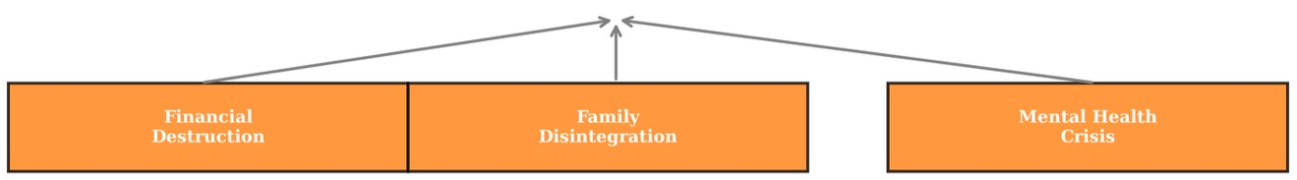
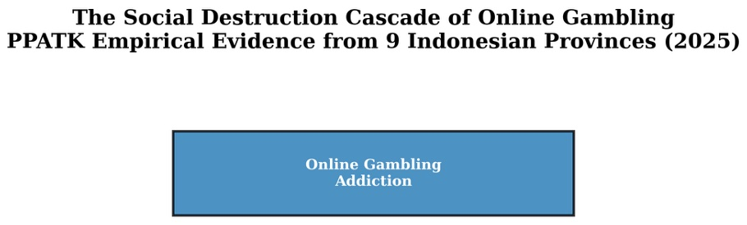

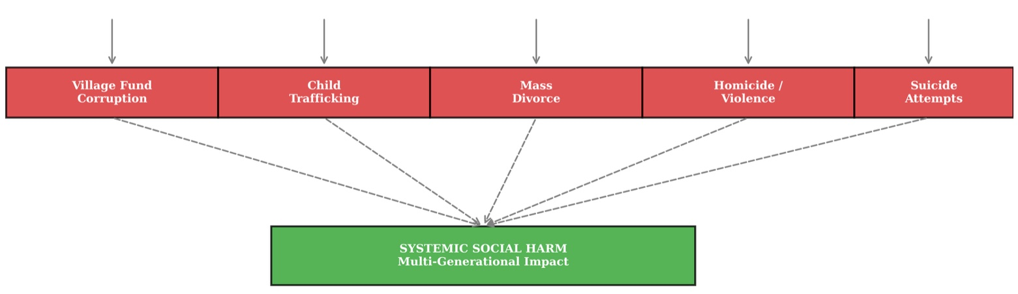

Figure 10. The social destruction cascade of online gambling: empirical evidence from nine provinces.
Source: Processed by authors from PPATK (2025).

4.2 The Regulatory Paradox: Blocking Supply Without Addressing Demand
The dormant account policy implemented in May 2025 produced the most significant short-term disruption of the online gambling ecosystem ever documented in Indonesia: deposits declined by 55% and transaction frequency by 78% within one month (Section 3.7). These figures suggest that the Indonesian state possesses meaningful regulatory capacity to intervene in digital financial markets, challenging the characterisation of developing states as powerless against transnational platform capital. However, a closer examination of the post-intervention data reveals a troubling paradox that we term the "regulatory paradox": supply-side financial disruption, while effective in the short term, leaves the structural determinants of demand untouched.
Three observations support this characterisation. First, post-policy monthly deposits of IDR 1.9–2.3 trillion remain extraordinarily high by historical standards - comparable to annualised figures that would have been considered unprecedented prior to 2021 (Section 3.7). The reduction, while dramatic in percentage terms, has brought the system back only to the level of approximately early 2023, not to the pre-exponential phase of 2017–2020. Second, the transaction frequency decline of 78% substantially exceeds the deposit value decline of 55%, indicating that players are consolidating their gambling activity into fewer but larger transactions - a behavioural adaptation that may reflect a shift from casual to more committed gambling among those who remain. Third, the relative stability of the June 2025 figure (IDR 1.9 trillion versus IDR 2.28 trillion in May) suggests that the initial shock is attenuating as players and operators adapt to the new regulatory environment.
This pattern mirrors the "hydra effect" described by Reuter (2014) for illicit drug markets: supply-side enforcement suppresses one manifestation of the market only for others to emerge through alternative channels. In the Indonesian case, the dormant account policy targets formal financial infrastructure - bank accounts, e-wallets, and QRIS merchant accounts. However, the underlying demand for gambling, which is driven by structural vulnerability (low income, limited economic mobility, and the psychological appeal of rapid wealth accumulation), remains unmet. Players whose accounts are terminated may migrate to cryptocurrency-based gambling platforms, peer-to-peer cash transfers through agents, or foreign-hosted platforms accessed via virtual private networks (VPNs). Indeed, preliminary PPATK data cited in key informant interviews (Interview FI-04, 2025) suggested a measurable increase in cryptocurrency wallet registrations from Indonesian IP addresses in the weeks following the dormant account policy implementation.
The regulatory paradox has a deeper theoretical dimension. Regulatory state theory, as articulated by Majone (1994) and Levi-Faur (2011), conceptualises the state as a rule-maker and enforcer that operates through delegated authority to private actors - in this case, banks, payment gateways, and e-wallet providers. The dormant account policy exemplifies this model: the state does not directly terminate accounts but mandates that financial service providers do so under their statutory obligations. However, this delegation creates principal-agent problems. Financial service providers face commercial incentives that may conflict with regulatory enforcement: gambling-related transactions generate fee income, account activity metrics, and customer engagement data that are valuable to the platform's business model. The effectiveness of delegated enforcement therefore depends on the robustness of monitoring, the severity of sanctions for non-compliance, and the alignment of commercial and regulatory incentives - conditions that are only partially met in the current Indonesian regulatory configuration.
The regulatory paradox deepens with the absence of demand-side interventions. The Indonesian state has concentrated its enforcement effort on supply-side measures: website blocking (Kominfo), transaction surveillance (PPATK), and account termination (OJK–Bank Indonesia coordination). No equivalent investment in demand-side measures exists: public health campaigns addressing gambling addiction, debt counselling services for affected families, school-based digital literacy programmes targeting children, or economic alternatives for structurally vulnerable populations. The theoretical implication is clear: regulatory state theory must account for the asymmetric effectiveness of supply-side versus demand-side interventions in digital markets where the demand is structurally embedded rather than merely opportunistic.

4.3 Indonesia in Comparative Perspective
Situating the PPATK findings within global estimates of the online gambling market. Independent industry analysts estimate the global online gambling market at approximately USD 65 billion in annual gross revenue (H2 Gambling Capital, 2024). The Indonesian data, with an annualised transaction flow of approximately IDR 600 trillion (USD 37.8 billion at prevailing exchange rates) for 2025, suggests that Indonesia alone accounts for a share of global online gambling transaction volume that is grossly disproportionate to its economic size. Even adjusting for the fact that transaction value includes both deposits and withdrawals (and thus double-counts some activity), the Indonesian market represents an estimated 31.5% of the global online gambling transaction universe - a share that is orders of magnitude larger than Indonesia's 3.5% share of global GDP.
Several factors may account for this disproportionality. First, Indonesia's prohibition regime creates a market structure in which transaction costs are higher and margins are wider than in regulated jurisdictions, potentially inflating the recorded transaction values relative to jurisdictions where gambling is legal and taxed. In regulated markets such as the United Kingdom, Australia, and parts of Europe, gambling operators pay licensing fees, comply with Know Your Customer (KYC) obligations, contribute to treatment funds, and face restrictions on marketing and credit offerings. In the unregulated Indonesian market, operators bear none of these costs, allowing them to offer more attractive odds and more aggressive marketing while retaining higher margins. The absence of legal supply constraints means that competition among operators drives user acquisition expenditure without the corresponding regulatory safeguards that would limit harm in a regulated environment.
Second, Indonesia's demographic structure - a young, increasingly urbanised, smartphone-saturated population of 280 million - provides a uniquely large and receptive market for digital gambling products. The global literature on gambling prevalence consistently identifies youth, male gender, urban residence, and smartphone access as risk factors for online gambling participation (Wardle et al., 2019; Abbott, 2020). Indonesia ranks among the highest globally in smartphone penetration and social media usage, and the mean age of the population is 29.7 years - squarely within the peak gambling participation bracket identified in Section 3.2. The combination of demographic endowment and technological access, when coupled with weak regulatory enforcement, creates conditions for gambling penetration that are unmatched in most other jurisdictions.
Third, the Indonesian case challenges the prevailing assumption in the global gambling literature that harm is primarily concentrated in high-income countries where gambling is legally commercialised. Wardle et al. (2019) and Gainsbury (2015) have documented the disproportionate burden of gambling-related harm on disadvantaged populations within high-income jurisdictions, but the Indonesian data suggest that the absolute magnitude of harm in developing states may far exceed that in wealthier countries, precisely because regulatory infrastructure, social safety nets, and treatment capacity are less developed. The presence of 103,100 minors, 6.9 million low-income adults, and catastrophic social harms (homicide, child-selling, corruption) at a scale that would be exceptional in any single jurisdiction suggests that the global burden of gambling harm is concentrated not in the regulated markets of the Global North but in the prohibition regimes of the Global South, where gambling is legally forbidden but technologically ubiquitous.
This finding carries implications for the international research agenda. The World Health Organization's classification of gambling disorder in ICD-11 (WHO, 2019) was based predominantly on evidence from high-income Western settings, and the treatment guidelines developed by bodies such as the National Institute for Health and Care Excellence (NICE) assume the availability of clinical infrastructure that is absent in much of the developing world. The Indonesian case demonstrates that the social harm burden of gambling in the Global South may be substantially higher than in the settings from which the evidence base is drawn, and that interventions developed for regulated markets may not be transferable to prohibition contexts. As Lim (2020) argues for Southeast Asian digital economies, imported Western regulatory models often fail in developing states with limited enforcement capacity, high informal activity, and weak consumer protection, including limited enforcement capacity, high levels of informal economic activity, and weak consumer protection frameworks.

4.4 Theoretical Implications for Digital Harm Research
The empirical patterns documented in this study carry implications for three theoretical domains: digital harm theory, structural vulnerability frameworks, and regulatory state theory.
Digital harm theory. The concept of digital harm has been primarily elaborated in the contexts of cyberbullying, online harassment, and child sexual exploitation (Livingstone & Helsper, 2007; Powell et al., 2018). This study extends digital harm theory to digital gambling, demonstrating that the harm architecture of gambling platforms - variable-ratio reinforcement, near-miss effects, loss-chasing affordances - operates through the same mechanisms of platform design that have been documented in other domains of digital exploitation. However, the Indonesian case reveals an important dimension that has been undertheorised in the existing literature: the role of payment infrastructure as a component of the harm architecture. Section 3.8 demonstrates that QRIS - a payment system designed for legitimate commerce - functions as a harm amplifier by lowering transaction friction to the point where gambling deposits require minimal cognitive effort. Digital harm theory must therefore extend beyond platform content and interface design to encompass the financial plumbing through which harm is operationalised. Zuboff's (2019) concept of "instrumentarian power" - the use of digital infrastructure to shape behaviour at scale - is directly applicable here: payment systems are active participants in behavioural modification, not passive conduits.
Structural vulnerability frameworks. The finding that 70.7% of players are low-income earners (Section 3.4) provides one of the most robust empirical confirmations to date of the structural vulnerability thesis for digital gambling. Quesada et al. (2011) argued that structural vulnerability is produced by the intersection of economic marginalisation, limited institutional access, and discriminatory social arrangements. The Indonesian data reveal the specific mechanisms through which this vulnerability is monetised: the poverty tax (Section 3.4), the Pinjol-Judol nexus (Section 3.9), and the absence of protective regulation that would limit gambling expenditure relative to income. The study contributes to the structural vulnerability literature by demonstrating a specific causal pathway: structural vulnerability → gambling as a perceived escape from precarity → gambling losses → deepened precarity → re-entry into the gambling cycle. This recursive loop, which we term the "gambling poverty trap," has been hypothesised in the theoretical literature (Raymen & Smith, 2020) but rarely documented at population scale with financial transaction data.
The structural vulnerability framework also illuminates the gender and age dimensions of the Indonesian case. The concentration of gambling among married men aged 26–45 (Section 3.2) reflects the gendered structure of economic responsibility in Indonesian households: men bear primary income-earning obligations, and their vulnerability to gambling addiction therefore has direct consequences for wives and children who depend on their earnings. The Religious Courts data (Section 3.6.1) reveal that women - the majority of divorce petitioners in gambling-linked cases - bear the secondary burden of addiction through financial neglect, harassment by debt collectors, and exposure to domestic violence. Structural vulnerability is thus not uniformly distributed even within households; it is refracted through gender hierarchies that amplify harm for women and children.
Regulatory state theory. The effectiveness of the dormant account policy (Section 3.7) provides important evidence for the regulatory state literature in the Global South context. Majone's (1994) original formulation of the regulatory state assumed a Western European institutional context with strong bureaucratic capacity, independent regulatory agencies, and a culture of compliance among regulated entities. The Indonesian case demonstrates that regulatory state theory can be extended to developing contexts, but with important modifications. The dormant account policy succeeded not because of the independent authority of a regulatory agency but because of the coordinated action of multiple state actors - PPATK (financial intelligence), OJK (financial sector regulation), Bank Indonesia (payment system oversight), and Kominfo (digital platform regulation) - operating through a presidential-level task force with coercive authority over financial institutions. This finding suggests that regulatory effectiveness in developing states may depend less on formal regulatory independence and more on the capacity for inter-agency coordination and political will at the highest levels of government.
However, the regulatory paradox identified in Section 4.2 reveals an important limitation of supply-side regulatory approaches in the absence of demand-side interventions. The literature on illicit market regulation (Reuter, 2014; Caulkins & Reuter, 2017) has long recognised that supply-side enforcement without demand reduction produces displacement effects rather than market elimination. The present study extends this insight to the digital domain, demonstrating that the hydra effect operates through multiple channels - alternative payment systems, cryptocurrency, cross-border platforms - that are intrinsic to the architecture of the internet. Regulatory state theory must therefore incorporate a theory of demand that accounts for the structural determinants of gambling participation, including economic insecurity, limited social mobility, and the cultural normalisation of gambling through digital marketing.

4.5 Policy Recommendations: A Multi-Stakeholder Framework
The evidence presented in this study supports the development of a comprehensive, multi-stakeholder policy framework that moves beyond the current reliance on supply-side enforcement alone. We propose six integrated policy domains, each targeting a different node in the gambling harm ecosystem.
Financial sector regulation (PPATK–banks–payment gateways). The dormant account policy has demonstrated the potential of financial sector intervention, but its effects may be extended and deepened through several complementary measures. First, mandatory real-time transaction screening for gambling-related patterns should be implemented across all QRIS-accepting merchant accounts, with particular attention to merchants whose transaction profiles deviate from their registered business category. Second, tiered transaction limits based on income verification should be introduced for digital payment instruments, capping daily and monthly deposit amounts for accounts that cannot demonstrate commensurate income. Third, the Pinjol-Judol nexus (Section 3.9) requires coordinated regulation: online loan platforms should be prohibited from disbursing funds to accounts identified as gambling-related, and credit scoring algorithms should incorporate indicators of gambling transaction patterns as negative factors. Fourth, a centralised gambling transaction database maintained by PPATK and accessible in real-time to financial service providers would enable more rapid identification and termination of gambling-linked accounts.
Digital platform regulation (Komdigi–law enforcement). The Ministry of Communication and Digital Affairs (Komdigi, formerly Kominfo) should move beyond website blocking - which is easily circumvented through VPNs and domain mirroring - toward more sophisticated supply-side interventions. These include: (a) mandatory age verification for all gambling-adjacent content (game advertisements, sports betting odds, casino simulations), enforced through platform liability provisions; (b) geoblocking requirements for social media platforms that host gambling advertisements targeting Indonesian users; (c) algorithmic de-prioritisation of gambling-related content on search engines and recommendation systems; and (d) enhanced international cooperation with domain registry authorities and hosting providers in jurisdictions that serve as safe havens for gambling operators. Law enforcement agencies should establish specialised cybercrime units with dedicated financial investigation capacity to pursue high-value operators rather than concentrating enforcement on low-level player prosecution.
Public health response (Ministry of Health–RSKD). The clinical equivalence between gambling addiction and narcotics addiction documented at RSKD (Section 3.6.6) demands a public health response commensurate with the scale of the problem. The existing three RSKD facilities with approximately 500 inpatient beds are manifestly inadequate for a population of 12.3 million players, of whom an estimated 2–4% (246,000–492,000) may meet clinical criteria for gambling disorder based on international prevalence rates (Williams et al., 2021). We recommend: (a) the establishment of gambling addiction treatment units within all provincial mental health facilities; (b) the integration of gambling disorder screening into primary healthcare protocols; (c) a national helpline and digital counselling service for gambling-affected individuals and families; and (d) the training of community health workers in gambling harm identification and referral. The public health approach should adopt the framework of "proportionate universalism" (Marmot, 2010), in which services are universally available but calibrated to the intensity of need in the most vulnerable populations.
Local government and community-based interventions. The spatial concentration of gambling harm in specific localities - Cengkareng (25% prevalence), the Jabodetabek cluster, and religious court jurisdictions with high gambling-linked divorce rates - suggests that local governments should play a central role in the response. We recommend: (a) local government ordinances requiring gambling harm awareness programmes in schools and community centres within high-prevalence areas; (b) integration of gambling-related indicators into village development planning, including mandatory reporting of village fund diversions; (c) training for religious court judges, social workers, and police in gambling addiction recognition and referral protocols; and (d) community-based peer support programmes modelled on successful substance abuse interventions in Indonesian community health centres (Puskesmas).
Family and household-level interventions. The evidence that gambling harm cascades from individual players to spouses, children, and extended family members (Section 3.6) supports interventions at the household level. These include: (a) financial counselling services for gambling-affected families, including debt restructuring and asset recovery support; (b) legal aid for wives seeking divorce or separation from gambling-addicted husbands, with particular attention to the protection of women from debt collection harassment; (c) school-based programmes for children identified as living in gambling-affected households, including psychological support and educational remediation; and (d) public awareness campaigns that reframe gambling addiction as a treatable health condition rather than a moral failing, reducing the stigma that prevents help-seeking.
Surveillance, evaluation, and adaptive regulation. Finally, the regulatory architecture should incorporate a continuous learning loop in which policy interventions are evaluated using the same financial intelligence data that revealed the scale of the crisis. The PPATK data infrastructure represents an unparalleled resource for regulatory evaluation, and the present study has demonstrated its utility for pre-post intervention analysis. We recommend: (a) the publication of periodic regulatory effectiveness reports by PPATK, including displacement indicators (cryptocurrency usage, VPN traffic to gambling sites, cross-border payment flows); (b) the establishment of an inter-agency research unit dedicated to gambling harm surveillance, with academic partners providing independent evaluation; and (c) the adoption of adaptive regulation principles in which intervention parameters are adjusted based on real-time data on player behaviour and market structure.

5. Conclusion
5.1 Summary of Key Findings
This study set out to answer three research questions concerning the scale, social harm, and regulatory responsiveness of online gambling in Indonesia. The findings, drawn from the triangulation of PPATK financial intelligence data covering 956 million transactions (2017–2025H1), demographic profiling of 12.3 million active players, and qualitative case documentation from nine provinces, provide comprehensive answers to each question.
RQ1: How has the scale and demographic distribution of online gambling in Indonesia evolved between 2017 and 2025? The data reveal an exponential trajectory unprecedented in the global gambling literature. Cumulative transaction value reached IDR 1,163 trillion (USD 73.4 billion), growing from IDR 2 trillion in 2017 to a projected IDR 600 trillion annualised run rate in 2025 - a compound annual growth rate of approximately 100% (Section 3.1). The demographic profile is characterised by four defining features: (a) concentration in prime working-age males (26–45 years), the primary income earners for most Indonesian households; (b) regressive economic distribution, with 70.7% of players (6.9 million individuals) earning less than IDR 5 million per month; (c) significant minor participation, with 103,100 players under 16 years old, including 36,400 children under 11; and (d) geographic concentration in the Jabodetabek megalopolitan region, with Cengkareng district recording a prevalence rate of 25% - five times the national average (Sections 3.2–3.5). Indonesia's estimated 31.5% share of global online gambling transaction value is grossly disproportionate to its 3.5% share of global GDP, reflecting the unique dynamics of prohibition regimes in digitally saturated developing economies.
RQ2: What social harms are empirically associated with online gambling at the individual and community level? The qualitative case documentation reveals a cascade of social destruction spanning five interconnected domains. Family dissolution is the most extensively documented harm: gambling-linked divorce accounted for 75.8% of cases in Cianjur (1,800 of 2,373), 70% of cases in Depok (where gambling and online loans are co-morbid), and 170 cases in Bojonegoro in the first four months of 2024 alone (Section 3.6.1). Beyond the domestic sphere, gambling addiction drove village fund corruption (Magelang: IDR 935 million embezzled), workplace homicide (Halmahera: civil servant killed coworker after IDR 130 million loss), child trafficking (Tangerang: father sold biological child for gambling funds), and a mental health crisis clinically equivalent to narcotics addiction (Sections 3.6.2–3.6.6). The Pinjol-Judol nexus - the systematic interconnection between online gambling and predatory online lending - operates as a two-tiered extraction mechanism that extends harm beyond the individual gambler to his entire relational network through debt collection harassment (Section 3.9). These findings demonstrate that the social harm of online gambling is not limited to financial loss but encompasses violence, corruption, family dissolution, child welfare violations, and public health crises.
RQ3: How effective are state policy interventions in disrupting the online gambling ecosystem? The dormant account policy implemented in May 2025 produced the most significant disruption of the gambling ecosystem ever documented: monthly deposit value declined by 55% (from IDR 5.08 trillion to IDR 2.28 trillion) and transaction frequency by 78% (Section 3.7). These effects demonstrate that the Indonesian state possesses meaningful regulatory capacity to intervene in digital financial markets through coordinated inter-agency action. However, post-policy deposits remain historically high at IDR 1.9–2.3 trillion per month, and the rate of decline attenuated between May and June 2025, suggesting the emergence of displacement effects as players adapt to the new regulatory environment. This pattern - a sharp initial impact followed by adaptation and partial recovery - is consistent with the hydra effect documented in illicit market regulation (Reuter, 2014). The central finding for policy is that supply-side financial intervention is necessary but not sufficient: the structural determinants of demand - economic precarity, limited social mobility, and the cultural normalisation of gambling through digital marketing - remain unaddressed.

5.2 Limitations
Six limitations of this study require acknowledgment. First, the PPATK financial data, while unprecedented in scale and coverage, are subject to systematic undercount. Transactions occurring through informal channels - cryptocurrency wallets, peer-to-peer cash transfers, and payments mediated by gambling agents - are not captured in the formal financial reporting system. The true scale of the online gambling phenomenon in Indonesia is therefore likely larger than the figures reported here. Second, the demographic data derived from KYC records may contain inaccuracies due to identity fraud, shared accounts, and the use of third-party payment accounts by proxy players. Prevalence rates calculated as a proportion of total population should be interpreted as lower-bound estimates of identified participants rather than true prevalence.
Third, the pre-post intervention analysis of the dormant account policy (Section 3.7) lacks a counterfactual control group. While the temporal proximity of the policy implementation to the observed decline in deposits and transaction frequency is suggestive of a causal effect, seasonal variation, simultaneous law enforcement operations, and supply-side disruptions unrelated to the account termination policy may confound the treatment effect. The absence of randomised assignment or a suitable comparison jurisdiction precludes strong causal inference. Fourth, the qualitative case selection, while purposively designed to capture maximum variation in harm types and geographic settings, is not statistically representative of all gambling-affected communities in Indonesia. The extreme cases documented in Section 3.6 (homicide, child-selling, corruption) illuminate mechanisms of harm but should not be interpreted as representative of the modal gambling experience.
Fifth, the study does not include primary data collection from gambling platform operators, payment intermediary executives, or international regulators, limiting our ability to characterise the supply side of the ecosystem from the perspective of those who design and operate the harm architecture. The analysis of supply-side dynamics relies on indirect evidence from transaction patterns, website blocking records, and key informant accounts rather than direct observation of platform operations. Sixth, the study period (2017–2025H1) captures a phase of exponential growth and one major policy intervention, but the long-term trajectory of the market remains uncertain. The displacement effects of the dormant account policy - particularly migration to cryptocurrency and cross-border platforms - require longitudinal data that extend beyond the current observation window to fully characterise.

5.3 Future Research Directions
The findings of this study open several avenues for further investigation. First, the displacement effects of the dormant account policy merit systematic empirical analysis using cryptocurrency transaction data, VPN usage metrics, and cross-border payment flow records. If, as preliminary indicators suggest, the supply-side financial intervention is driving players toward less regulated payment channels, then the policy may be inadvertently funnelling gambling activity into forms that are even harder to monitor and regulate - a classic unintended consequence of prohibition regimes. Longitudinal tracking of alternative payment channel adoption among Indonesian gamblers would provide critical evidence for designing the next generation of regulatory interventions.
Second, the Pinjol-Judol nexus (Section 3.9) requires deeper investigation through financial network analysis that maps the interconnections between gambling operators, online loan platforms, and common payment intermediaries. The present study has documented the co-occurrence of gambling and online loan debt at the individual level (70% of Depok divorce cases), but the structural relationships between the two industries - including common ownership, shared marketing channels, and data-sharing arrangements - remain opaque. A network analysis approach, potentially leveraging PPATK's transaction-level data under strict ethical protocols, could reveal the architecture of the gambling-lending complex and identify leverage points for coordinated regulatory intervention.
Third, the long-term welfare consequences of gambling participation for low-income households constitute a pressing research priority. The present study has documented the immediate financial impact (8.1% of monthly income diverted to gambling) and the catastrophic social outcomes, but the medium-term effects on child educational attainment, household asset accumulation, intergenerational economic mobility, and mental health trajectories remain unmeasured. A cohort study tracking gambling-affected households over a 3–5 year horizon, combining financial record analysis with repeated survey measurement of well-being indicators, would provide the evidence base for cost-benefit analysis of alternative regulatory strategies.
Fourth, comparative research across Southeast Asian jurisdictions - Malaysia, Thailand, Vietnam, the Philippines - would illuminate the institutional and cultural factors that moderate the relationship between prohibition regimes and gambling prevalence. The Philippines, which has legalised and regulated online gambling through the Philippine Amusement and Gaming Corporation (PAGCOR), offers a useful counterfactual: does legal regulation reduce the social harm burden relative to prohibition, or does it simply shift the distribution of harm while expanding the total market? Cross-national comparative analysis using standardised harm indicators would enable evidence-based policy transfer and the identification of regulatory best practices for the Southeast Asian context.
Fifth, the question of treatment effectiveness in low-resource settings demands rigorous evaluation research. The clinical protocols developed for gambling disorder in high-income settings - cognitive-behavioural therapy, motivational interviewing, pharmacological intervention - have not been systematically tested in Indonesian populations, where cultural attitudes toward gambling, help-seeking behaviour, and family dynamics differ substantially from the Western contexts in which these protocols were developed. Randomised controlled trials of adapted treatment programmes, delivered through existing primary healthcare infrastructure, would provide the evidence base for scaling up the public health response recommended in Section 4.5.
Finally, the methodological approach developed in this study - the triangulation of financial intelligence data, demographic profiling, and qualitative case documentation - offers a template for studying illicit digital markets in other developing state contexts where conventional survey methods are impractical or unreliable. The availability of administrative data from financial intelligence units, combined with the creative use of judicial records and institutional administrative data, can overcome the limitations of self-report surveys in settings where gambling is legally prohibited and therefore stigmatised. Future research should explore the transferability of this methodological framework to other prohibited digital markets - including illegal drug trading, illegal lending, and online fraud - where similar patterns of financial infrastructure exploitation and socially regressive harm distribution may be observable.

REFERENCES
Braun, V., & Clarke, V. (2006). Using thematic analysis in psychology. Qualitative Research in Psychology, 3(2), 77-101. https://doi.org/10.1191/1478088706qp063oa
Brown, S. (2021). Digital harm and the political economy of platform design. New Media and Society, 23(8), 2291-2310. https://doi.org/10.1177/1461444820928054
Creswell, J. W., & Plano Clark, V. L. (2018). Designing and conducting mixed methods research (3rd ed.). SAGE Publications.
Farmer, P. (2004). Pathologies of power: Health, human rights, and the new war on the poor. University of California Press.
Fetters, M. D., Curry, L. A., & Creswell, J. W. (2013). Achieving integration in mixed methods designs. Health Services Research, 48(6), 2134-2156. https://doi.org/10.1111/1475-6773.12117
Gainsbury, S. M. (2015). Online gambling addiction: The relationship between internet gambling and disordered gambling. Current Addiction Reports, 2(2), 185-193. https://doi.org/10.1007/s40429-015-0057-8
Guetterman, T. C., Fetters, M. D., & Creswell, J. W. (2015). Integrating quantitative and qualitative results in health science mixed methods research through joint displays. Annals of Family Medicine, 13(6), 554-561. https://doi.org/10.1370/afm.1865
Haryono, A., & Rahayu, S. (2022). Regulatory challenges in combating online gambling in Indonesia. Journal of Southeast Asian Economies, 39(1), 67-89.
Langham, E., Thorne, H., Browne, M., Donaldson, P., Rose, J., & Rockloff, M. (2016). Understanding gambling related harm: A proposed definition, conceptual framework, and taxonomy of harms. BMC Public Health, 16(1), 80. https://doi.org/10.1186/s12889-016-2747-0
Levi-Faur, D. (2011). Regulation and regulatory governance. In D. Levi-Faur (Ed.), Handbook on the politics of regulation (pp. 1-25). Edward Elgar Publishing.
Majone, G. (1994). The rise of the regulatory state in Europe. West European Politics, 17(3), 77-101. https://doi.org/10.1080/01402389408425031
Muggleton, N., Parpart, P., Newall, P., Leake, D., Gathergood, J., & Stewart, N. (2021). The association between gambling and financial, social, and health outcomes in big financial data. Nature Human Behaviour, 5(3), 319-326. https://doi.org/10.1038/s41562-020-01045-w
Nugroho, A. B. (2023). State capacity and legal enforcement in Indonesia's online gambling prohibition. Asian Journal of Criminology, 18(2), 145-167.
Powell, A., Stratton, G., & Cameron, R. (2018). Digital criminology: Crime and justice in digital society. Routledge.
PPATK. (2025). Strategic analysis report on online gambling in Indonesia, 2017-2025. Pusat Pelaporan dan Analisis Transaksi Keuangan.
Quesada, J., Hart, L. K., & Bourgois, P. (2011). Structural vulnerability and health: Latino migrant laborers in the United States. Medical Anthropology, 30(4), 339-362. https://doi.org/10.1080/01459740.2011.576725
Raymen, T., & Smith, O. (2020). The chimeric dream of the 'good life' in late modernity: Gambling and the politics of hope. British Journal of Criminology, 60(4), 884-902.
Reuter, P. (2014). On the multiple sources of the hydra effect in illicit markets. Crime and Justice, 43(1), 1-42.
Sari, D. P., Putri, A. N., & Hidayat, R. (2023). Gambling behaviour and household financial distress in urban Indonesia. Journal of Gambling Studies, 39(4), 1123-1142.
Wahyuni, S., & Pratama, Y. (2024). Lived experiences of online gambling addiction among young adults in Java. International Journal of Mental Health and Addiction, 22(2), 456-473.
Wardle, H., Reith, G., Langham, E., & Rogers, R. D. (2019). Gambling and public health: A global perspective. The Lancet Public Health, 4(7), e330-e331. https://doi.org/10.1016/S2468-2667(19)30100-9
Williams, R. J., Volberg, R. A., & Stevens, R. M. G. (2021). The population prevalence of problem gambling: Methodological influences, standardized rates, jurisdictional differences, and worldwide trends. Ontario Problem Gambling Research Centre.
World Health Organization. (2019). International classification of diseases for mortality and morbidity statistics (11th ed.). https://icd.who.int/
Yin, R. K. (2018). Case study research and applications: Design and methods (6th ed.). SAGE Publications.

